Physical Development Educational Programme
Physical activity is vital in children’s all-round development, enabling them to pursue happy, healthy and active lives. Gross and fine motor experiences develop incrementally throughout early childhood, starting with sensory explorations and the development of a child’s strength, co-ordination and positional awareness through tummy time, crawling and play movement with both objects and adults. By creating games and providing opportunities for play both indoors and outdoors, adults can support children to develop their core strength, stability, balance, spatial awareness, co-ordination and agility. Gross motor skills provide the foundation for developing healthy bodies and social and emotional well-being. Fine motor control and precision helps with hand-eye co-ordination which is later linked to early literacy. Repeated and varied opportunities to explore and play with small world activities, puzzles, arts and crafts and the practise of using small tools, with feedback and support from adults, allow children to develop proficiency, control and confidence.

Early Learning Goal: Fine Motor Skills
- Hold a pencil effectively in preparation for fluent writing – using the tripod grip in almost all cases;
- Use a range of small tools, including scissors, paint brushes and cutlery;
- Begin to show accuracy and care when drawing.

Burnham-on-Sea Intent
Our main intent will be to develop children’s skills with scissors, a knife and fork and securing the tripod grip.

In everyday practice and provision, the children will be given the opportunity to develop their proficiency, control, confidence and hand-eye co-ordination through using resources such as, tweezers, nuts and bolts, clothes pegs, ribbon sticks, construction equipment (Lego), gardening tools, a range of paint brushes (fine, thick and roller), sculpting clay tools and a selection of writing implements (pencils, pens, crayons, chalk). In addition, there will be a daily fine motor skills (funky fingers) focus.

Refer to Development Matters for any further guidance needed for specific cohort learning and development needs.

Intent  Precision of Movement | Fine Motor Strength Skill | Term 1 | Term 2 | Term 3
Coordination  Control  Confidence | Knife and fork | Use a fork (an adult has cut up the food). | Maintain a correct grip on knife and fork when positioned by an adult. Be able to cut with the knife. | Maintain a correct grip on knife and fork without assistance. Be able to cut with the knife and eat with the fork.
Impact

Percentage of children who are secure.

Who needs more experience or a different learning opportunity?

Record children’s initials

How will we do this?

Consideration needs to be given to the resources provided. For example, using Caring Cutlery which is designed to support children to effectively use a knife and fork. This would be replicated in both the dinner hall and the EYFS classroom (the home corner and the malleable area). Learning in each term could be deepened by providing children with a varying degree of challenge in the materials they are asked to cut (playdough, plasticine, putty and clay).

Children who need more experience or a different learning opportunity are highlighted when progress has been made. Annotations may be added on this sheet (if necessary) or within any other child progress documentation recorded by the school.

Intent  Precision of Movement | Fine Motor Strength Skill | Term 1 | Term 2 | Term 3 | Term 4 | Term 5 | Term 6
Coordination  Control  Confidence | Cutting with scissors | Maintain a correct grip on scissors when positioned by an adult . Be able to open and close scissors. | Maintain a correct grip on scissors without assistance. Be able to open and close scissors using a controlled action. Hold paper and make small random snips. | Cut straight lines across a page. | Cut simple curves and angled lines (one direction change) | Cut simple lines with more than one direction change (zig zag line). Cut out a circle. | Cut complicated shapes with straight and curved lines.
Impact
Percentage of children who are secure.
Who needs more experience or a different learning opportunity?

Record children’s initials
How will we do this?

Consideration needs to be given to the resources provided. For example, using loop scissors or dual scissors which are designed to support children in developing effective scissor skills.

Learning in each term could be further deepened by providing children with scissors of varying sizes and types (zig zag) or providing card instead of paper to cut. Both right-handed and left-handed scissors will be provided.

Children who need more experience or a different learning opportunity are highlighted when progress has been made. Annotations may be added on this sheet (if necessary) or within any other child progress documentation recorded by the school.

Intent  Precision of Movement | Fine Motor Strength Skill | Autumn Term  Continues throughout the year to for strength, stamina and precision
Coordination  Control  Confidence | Tripod pencil grip | Pencil Grasp  Provide resources with tongs that encourage the use of the thumb, index and middle finger while working the tiny muscles in that nook between the thumb and index. For example, Patch Bed Bugs, Operation, Wok and Roll or Hungry Monkey Motor Skills Game. Provide bubble wrap with children using their tripod fingers to pop the bubbles.  Positioning  Provide smaller writing implements as they naturally encourage a proper grasp. Encourage the child to rest the ulnar side (the little finger) of their hand on the page when they are writing or drawing. This helps to stabilise the hand.  Posture  Provide vertical surfaces as this places the wrist in a good position for writing e.g., use pizza boxes. |  | Pencil Grasp  Teach how to hold the pencil correctly.  Resources to support height and positioning that we might use:  1. The Claw Pencil Grip.  2. The Grotto Grip.  3. Twist N Write Pencil.  4. The Dolphin Grip  5. Place an elastic band/hair band around the end of the pencil.  6. Place a small pom pom or marble in your hand under ruby ring and baby small.  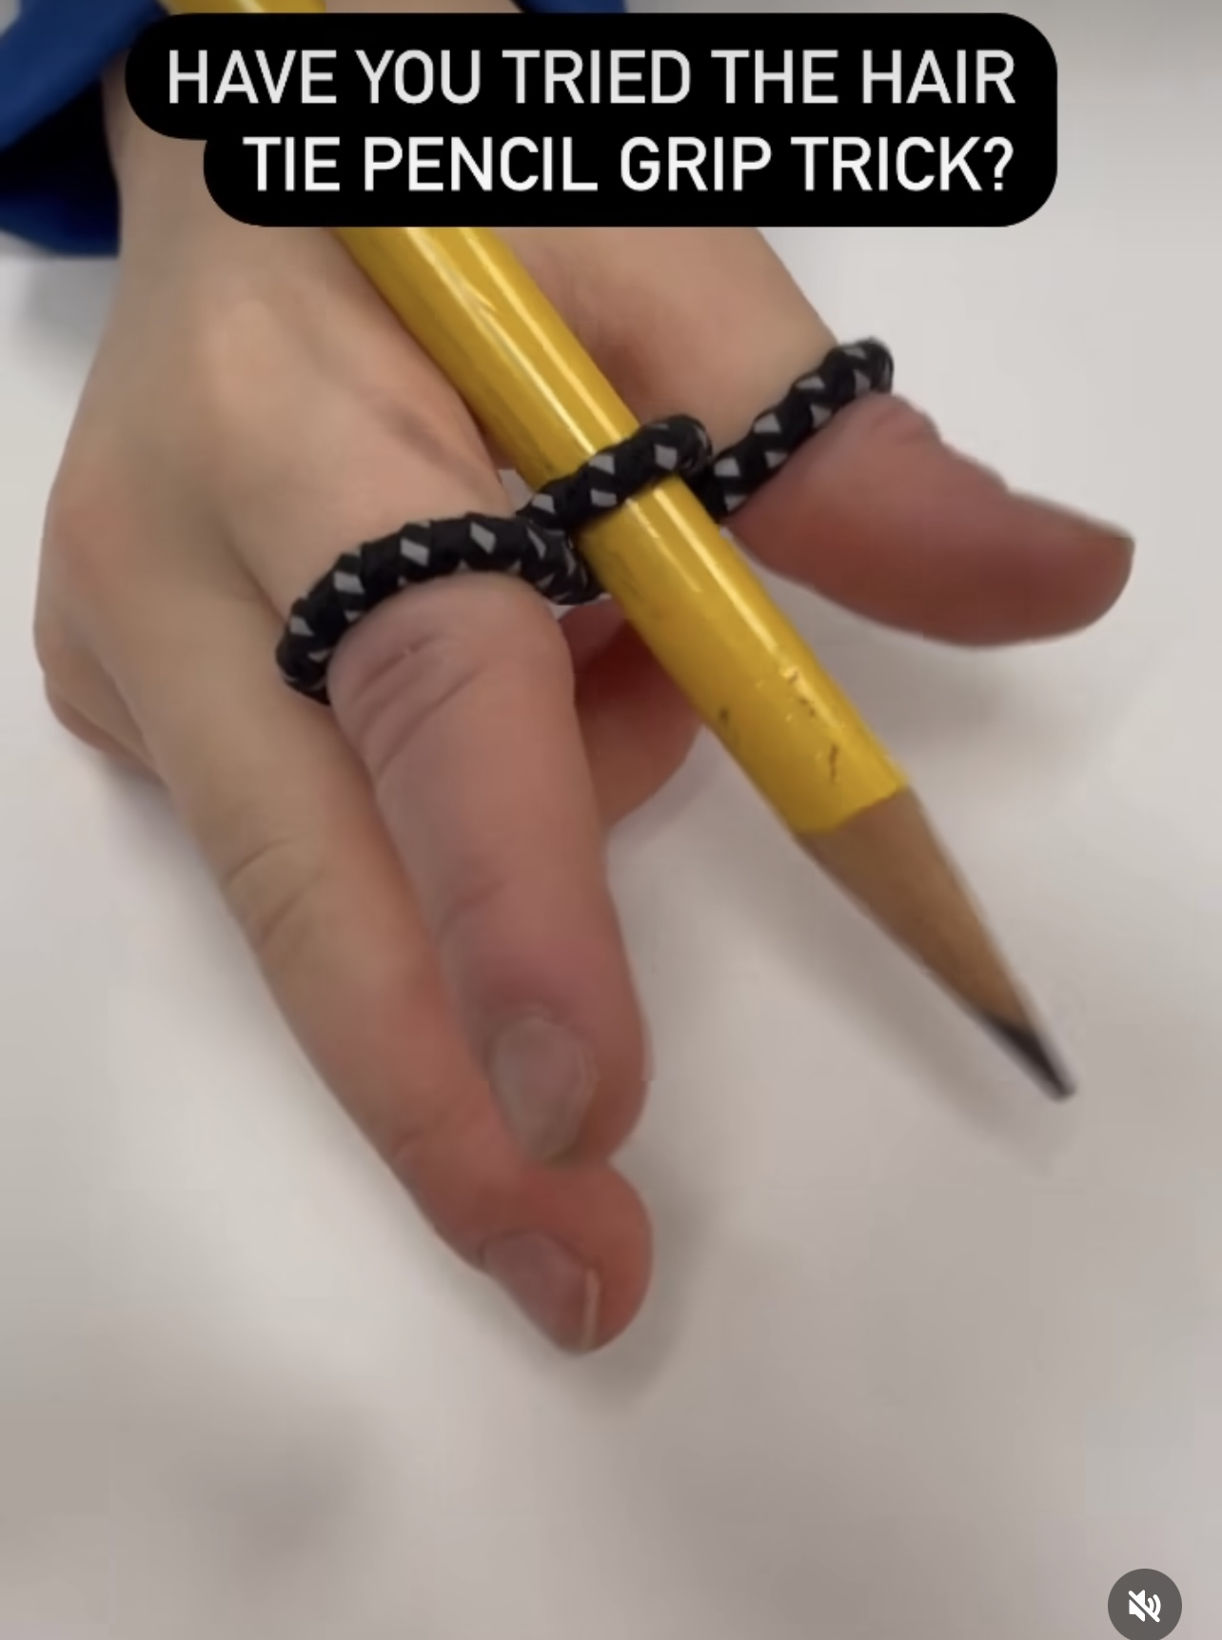  Strategies to support this that we might use:  1. Nip, grip and flip.  2. Ali the Alligator: chomp two fingers on top of one finger. Flip it. This could be draw on children’s hands.  3. Rhyme:  My thumb is bent.  My pointer points to the tip.  Tall man uses his side.  I tuck two fingers in and take them for a ride.
Intent  Precision of Movement | Fine Motor Strength Skill | Autumn Term  Continues throughout the year to for strength, stamina and precision
Coordination  Control  Confidence | Tripod pencil grip | Hand and Finger Movements  Teach children to isolate fingers. For example, one finger up and four fingers down, two fingers up and three fingers down). Sing finger rhymes (Tommy Thumb and Here is a Church).  Teach other finger skills as recommended by occupational therapists. For example, each finger to touch the thumb (one at a time), kiss each fingertip or running fingers along the table. | Pressure  Demonstrate how to sit at a table and how to position paper.  Focus on applying pressure when using a pencil and drawing the following shapes:  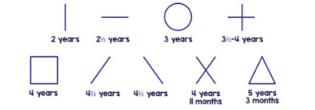
Percentage of children who are secure.

Who needs more experience or a different learning opportunity?

Record children’s initials?

How will well do this?

Children who need more experience or a different learning opportunity are highlighted when progress has been made. Annotations may be added on this sheet (if necessary) or within any other child progress documentation recorded by the school.

