

Welcome to Dolphin Class SEND Unit
Nurturing Minds, Developing Potential, Enriching Futures
The aim of this booklet is to inform parents and carers of the ways in which our school welcomes, effectively supports and adapts provision for children with special educational needs and/or disabilities (SEND) to ensure that all children, no matter their need, will thrive and progress at Burnham on Sea Infant School.
All staff at our school welcome children with additional needs and work hard to provide an inclusive environment that embraces the range of pupils who attend our setting. We not only follow the statutory guidelines within the; Special Educational Needs Code of Practice for children 0 to 25 Years (Department for Education and Department of Health, 2015) but strongly value our unique school community and work hard to support all of its members.
Our school values of being ‘kind’, ‘curious’ and ‘dedicated’, are the core aim in everything we do and we were proud that Ofsted recognised:
‘Pupils enjoy coming to this friendly school, where mutual respect is a strong feature of the positive relationships between pupils and adults. Adults create a safe, nurturing environment that builds trust and confidence in pupils. Pupils show a deep understanding of the need to acknowledge and respect individual differences.’
(Ofsted Report, 2023)

About Our SEN Unit - Our Ethos and Values

In September, 2025, we successfully opened our SEN Unit within our school site. This is based on our strong belief that children with additional needs have the right to be educated within their community and embraced and accepted within an inclusive but ambitious culture. Sitting alongside our mainstream classes, Dolphin Class has a designation for supporting children with cognition and learning difficulties, particularly around speech, language and communication. It is a 9 place unit with its own dedicated learning environment, including entrance/exit and outside space. Spaces are allocated for children with an EHCP through the local authority SEND team.
St Andrews Church Junior School, our local feeder school, has a SEND Unit opening 2026-27 academic year so that children have a clear pathway for their needs to be met.

We believe every child deserves to feel safe and valued, develop confidence and independence, achieve their full potential and be included in all aspects of school life
Our SEN Unit provides a nurturing, inclusive, and supportive environment for children with cognition and learning challenges, particularly with speech and language difficulties.
We focus on:
- individual learning plans linked to EHCP targets and underpinned by the Equals Curriculum
- Small group teaching
- Access to mainstream activities (where appropriate)
- Speech, language, and communication development
- Social and emotional support

Staffing:
   
Headteacher: Carly Hatch SENCo: Shirley Marriott Class Teacher: Helen Lock HLTA: Michelle Stannard (PPA)

SEN Education Support Assistants:

Karina Kilpin, Kirsty Powell Angela Medhurst Kelly Wiles Vicki Burch
These staff work across both Burnham on Sea Infant School and St Andrews SEND Units

Our School Day

The school day for children in Dolphin Class begins at 8.30am and finishes at 3pm. The classroom has it’s own dedicated entrance around the side of the school and into the dedicated outdoor environment. The school day is staggered from the rest of the school to ensure a calm and quiet start and finish to the school day to support children’s emotional regulation.
Throughout the day children are provided opportunities for sensory and experiential play, alongside dedicated carpet sessions, adult directed tasks and targeted support to meet individual EHCP targets using both the inside and outside environments. Children are encouraged to develop their independence and build their confidence to communicate from a range of strategies and tools available.

Children in Dolphin Class, dependent on their needs, may have playtimes with the main school, supported by familiar adults from the classroom. Lunch is eaten within the classroom in the children’s safe and familiar environment. Children are welcome to eat a hot meal prepared by Aspens, our school meal provider or a lunch box from home. Meals provided by Aspens are free for all children as part of the universal free school meal offer. Children will also receive a free fruit/vegetable snack each day or a snack of parental choice provided from home. 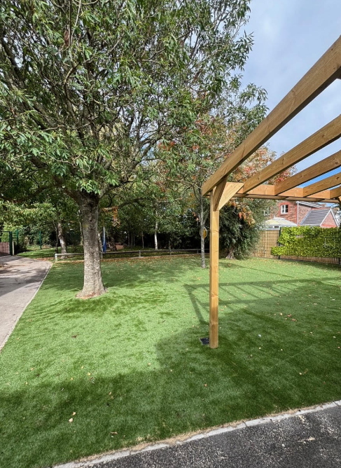 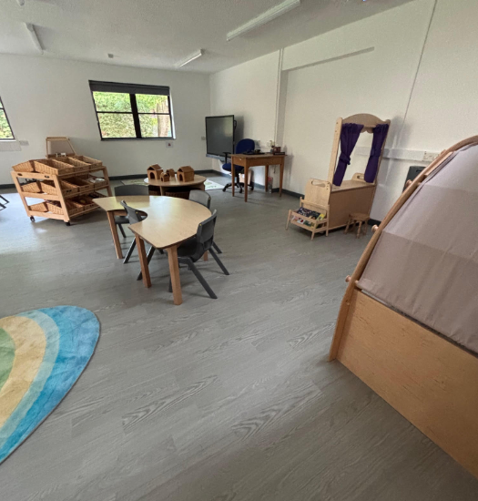 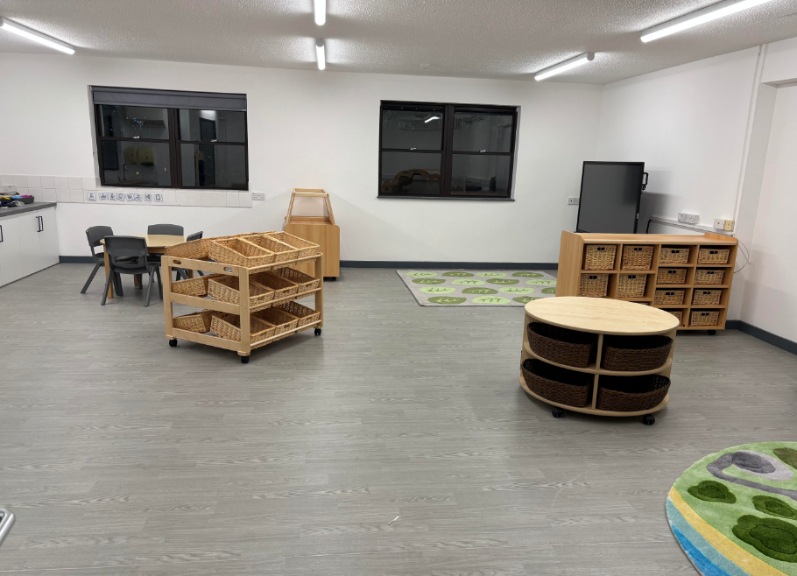

Our Curriculum

As a Unit we use the Equals Curriculum to support the provision and meet individual needs. We have broad overarching half termly themes based upon ‘the world around us’ alongside concepts that we revisit throughout the year. This enables us to maximize children’s interests as a vehicle for learning.
 | Over Arching ‘The World Around Us’ Theme | Whole Year Concepts
Autumn (1) | People | Seasons  Festivals  Weather  Passing of time  Use of technology  Water
Autumn (2) | Food / Clothing
Spring (1) | Animals and Plants
Spring (2) | Life cycles
Summer (1) | Recycling / looking after the environment
Summer (2) | Materials

To provide a broad and holistic development for each child, each half term all children have 8 bespoke targets, linked to their EHCP and individual needs for the following areas:
- Communication
- Relationships and play
- Independence
- Thinking and Problem Solving
- Well being
- Overarching Theme
- Phonics/Literacy
- Maths/Numerical Patterns

For each target/skill area, children are assessed along a 10 point scale for independence, fluency, maintenance and generalization.

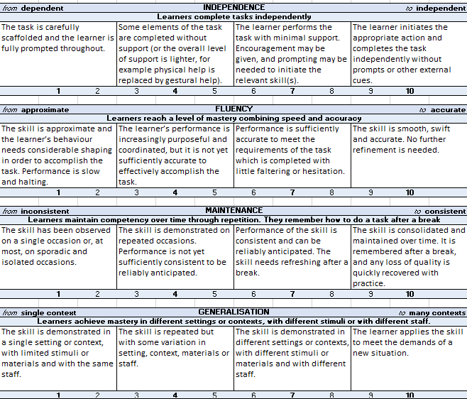
This is reviewed regularly and used to inform provision and planning.

Supporting Emotional Wellbeing

Our team supports children by:
-Building relationships and getting to know each child as an individual
- Using visual timetables
- Creating calm, predictable routines
- Offering sensory breaks and sensory circuit opportunities around the school
- Teaching emotional regulation strategies – all children across the school use Zones of Regulation to develop their understanding and share their emotions with others. We have a number of different regulation stations around the school which provide a space and strategies to help children regulate their emotions.
- Providing key adults for reassurance

Specialist Support
Depending on your child’s needs, they may have access to:
Speech and Language Therapy (internal and/or external support)
Occupational Therapy
Educational Psychology
Autism Outreach or Support Services
Draw and Talk Therapy
Trust Parent and Family Support Advisor
A range of interventions / targeted support strategies
We work collaboratively with these professionals to ensure joined-up care.

Communication with Parents

We value strong partnerships with families. You can expect:
- Daily contact through your child’s communication book
- Regular progress updates, including parents consultations
- Open-door policy for quick chats or concerns
- Parent workshops
- Celebration events
- Use of the school app and website to keep you up to date with school events and messages.
- More information can be found on our school website at https://www.burnhaminfants.com/
Please don’t hesitate to contact us by phone, email, or message if you have any questions.

Starting School in Dolphin Class – Our Transition Timeline

Stage | What Happens | Who’s Involved
Before joining | Visits to the SEN Unit / Transition meetings, School Entry Plan Meeting and Plan created, short taster sessions for children | SENCo, parents, current school/nursery, SEN staff, child
On starting | Gradual start moving to full-day placement - see below (depending on need) | SEN staff, parents
End of first half term | Review meeting to discuss how your child is settling | Parents, SENCo, class teacher
Transition Plan
Week 1 - mornings 8.30am - 11.30am
Week 2 - mornings and lunch 8.30 am - 12.30
Week 3 - whole day Monday, Wednesday, Friday, (8.30 - 3pm) mornings with lunch Tuesday and Thursday

If your child requires a more bespoke/ longer transition into school this will be discussed and planned as part of the school entry plan meeting. This meeting is held with parents, current setting and any supporting agencies with your child and what they need placed at the center.

Preparing Your Child for Starting School in Dolphin Class

Here are some ways to help your child feel ready:
- Talk positively about their new school and teachers.
- Look at pictures of the classroom and staff (included in this booklet).
- Practice routines such as putting on a coat, opening lunch boxes, and using the toilet independently (if appropriate)
- Read social stories about starting school in Dolphin Class (shared by school once your child is allocated a place with us)
- Visit the school. Please contact the school office to make an appointment.

What Your Child Will Need

- Comfortable school uniform (labelled with their name). Our provider is Price and Buckland.
- Packed lunch or school meal arrangement
- Water bottle
- Spare clothes (if appropriate)
- Communication book (provided by school)
- Welly boots and outside play suit/waterproofs (we go outside in all weathers!)

Important Dates and Contacts
Contact | Role | Email | Phone
Shirley Marriott | SENCo | senco@bosi.theplt.org.uk | 01278 782342
Carly Hatch | Headteacher | Carly.hatch@bosi.theplt.org.uk | 01278 782342
School office | Admin Office | office@bosi.theplt.org.uk | 01278 782342

Term Dates 2026 - 2027

Term 1 | Start Thursday 3rd September 2026 End Friday 23rd October 2026.  Inset day Thursday 3rd and Friday 4th September. Children return to school Monday 7th September.
Term 2 | Starts Monday 2nd November 2026 Ends Friday 18th December 2026  Inset day Monday 2nd November. Children return to school Tuesday 3rd November
Term 3 | Starts Monday 4th January 2027 Ends Friday 12th February 2027  Inset day Monday 4th January. Children return to school Tuesday 5th February.
Term 4 | Starts Monday 22nd February 2027 Ends Thursday 25th March 2027
Term 5 | Start Monday 12th April 2027 End Friday 25th May 2027  Inset day Monday 12th April. CHildren return to school Tuesday 13th April 2027.
Term 6 | Start Monday 7th June End Friday 23rd July 2027  Inset day Monday 7th June. Children return to school on Tuesday 8th June.

Final Thoughts

We are delighted to welcome your child into our Dolphin Class, SEN Unit family.
Every child’s journey is unique, and we are committed to helping them thrive — academically, socially, and emotionally.
If you have any questions or concerns, or would like to find out more and arrange a visit, please do not hesitate to get in touch via the school office.

office@bosi.theplt.org.uk
01278 782342

