Pupil premium strategy statement Burnham on Sea Infant School

This statement details our school’s use of pupil premium funding to help improve the attainment of our disadvantaged pupils.
It outlines our pupil premium strategy, how we intend to spend the funding in this academic year and the outcomes for disadvantaged pupils last academic year.

School overview
Detail | Data
Number of pupils in school | 153
Proportion (%) of pupil premium eligible pupils | 20%
Academic year/years that our current pupil premium strategy plan covers (3-year plans are recommended – you must still publish an updated statement each academic year) | 2024 - 2027  Reviewed December 2025
Date this statement was published | December 2025
Date on which it will be reviewed | December 2026
Statement authorised by | Carly Hatch
Pupil premium lead | Carly Hatch, Headteacher
Governor / Trustee lead | Kerry Jones

Funding overview

(18,929.93)
(29,163.75)
(264.78)
(408.33)

Detail | Amount
Pupil premium funding allocation this academic year | £ 48,766
Pupil premium funding carried forward from previous years (enter £0 if not applicable) | £0
Total budget for this academic year  If your school is an academy in a trust that pools this funding, state the amount available to your school this academic year | £48,766

Part A: Pupil premium strategy plan

Statement of intent
At Burnham on Sea Infant School, we are committed to ensuring that every child has the opportunity to achieve their full potential, regardless of their background or circumstances. We recognise the challenges faced by disadvantaged pupils and are dedicated to providing targeted support to address these barriers to success. Our statement of intent for pupil premium and disadvantaged pupils in our primary schools outlines our commitment to equity, inclusion, and excellence in education.
Our intention is clear: to empower all pupils, irrespective of their socio-economic background or the challenges they may face, to make significant progress and achieve high levels of attainment across all subject areas. We firmly believe that every child has the right to access quality education and that no child should be left behind due to circumstances beyond their control.
The focus of our pupil premium strategy is to provide tailored support to disadvantaged pupils, including those eligible for Free School Meals (FSM), children in care, and those from service personnel families. We understand the importance of removing financial barriers to education and we are dedicated to closing the attainment gap by ensuring that these pupils receive the additional resources, interventions, and opportunities they need to thrive academically and socially.
Research demonstrates that pupils from deprived backgrounds often underachieve
compared to their peers. Therefore, it is imperative that we utilise pupil premium
funding effectively to enable these pupils to succeed. Our approach is rooted in
evidence-based practices and informed by robust diagnostic assessment, ensuring
that support is targeted and impactful.
We adopt a whole-school approach, with every staff member taking responsibility for
the outcomes of disadvantaged pupils. We foster a culture of high expectations,
where we believe in the potential of every child and are committed to challenging
them to reach new heights of achievement. Early intervention is key, and we act
swiftly to address any barriers to learning as soon as they are identified.
Our commitment to the success of disadvantaged pupils extends beyond academic
achievement. We strive to nurture their holistic development, supporting their social,
emotional, and well-being needs to ensure they flourish both inside and outside the
classroom.
In conclusion, at Burnham on Sea Infant School, we are dedicated to championing the rights of
disadvantaged pupils and maximising their potential through targeted support, high
expectations, and a commitment to excellence. By working collaboratively with
families, stakeholders, and the wider community, we aim to create a nurturing and
inclusive environment where every child can thrive and succeed.

Challenges
This details the key challenges to achievement that we have identified among our disadvantaged pupils.
Challenge number | Detail of challenge
1 | Low literacy levels on entry and low standards in Reading, Writing and Maths
2 | Correlation between pupils who are Pupil Premium and also have SEND 14/31 children who are pupil premium also have SEND needs
3 | Attendance
4 | Financial pressures for families
5 | Pupil confidence and resilience

Intended outcomes
This explains the outcomes we are aiming for by the end of our current strategy plan, and how we will measure whether they have been achieved.
Intended outcome | Success criteria
All disadvantaged pupils make expected or better progress from their starting points | The percentage of disadvantaged pupils  achieving Age Related Expectations is  above the national average.  Progress for all disadvantaged pupils is  above zero on Insight Tracking.
The school’s curriculum offers disadvantaged  pupils an engaging, structured and relevant  curriculum with a wide range of high quality  learning experiences, including meeting the needs of pupils with SEND. | Pupils’ learning demonstrates rich and  stimulating learning across the curriculum  with learning built up progressively across  the primary phase.  Pupils are able to talk about how their  learning has built up over several years and  can describe how learning links together.  Disadvantaged pupils can talk about a wide  range of experiences and activities which  they have engaged with.
Attendance of disadvantaged pupils is high  compared to national averages for both  disadvantaged and non-disadvantaged pupils | Analysis of attendance figures highlight that  attendance for disadvantaged pupils is  above national averages for disadvantaged  and non-disadvantaged pupils.
Disadvantaged pupils are confident, resilient  and independent demonstrating positive  attitudes to learning | Pastoral and emotional support for pupils  and families is firmly embedded within the  school.  Pupils and families can talk about the  support they have received from the school.  Outcomes and behaviour for learning for  targeted pupils improves.
Pupils with SEND challenges receive  appropriate support to enable them to  make good progress in their learning | The school has clear procedures and interventions to support pupils with SEND.  Pupils with SEND make progress in their learning, tracked and documented through the graduated response and use of Insight Tracking.

Activity in this academic year
This details how we intend to spend our pupil premium funding this academic year to address the challenges listed above.

Teaching (for example, CPD, recruitment and retention)
Budgeted cost: £5,000
Activity | Evidence that supports this approach | Challenge number(s) addressed
Improve teaching and  learning through  developed coaching  programme | Improved teaching and learning will enable all pupils to make better progress. The coaching approach enables regular professional dialogue and development tailored to the needs  of individuals. | 1, 2, 5
Improve Oracy skills for pupils through implementation of 3 year program Voice 21 | Improved oracy skills will provide strong foundations for reading and writing, alongside building confidence in pupils to articulate their thoughts and ideas.  Commission on the Future of Oracy Education in England’s We Need To Talk report | 1, 2, 5

Targeted academic support (for example, tutoring, one-to-one support, structured interventions)
Budgeted cost: £32,000
Activity | Evidence that supports this approach | Challenge number(s) addressed
High quality, structured interventions during  afternoon sessions for disadvantaged pupils | Smaller group interventions allow pupils’ individual needs to be met more  appropriately. Pupils will be able to revise key concepts and consolidate  their knowledge and understanding | 1, 2,5
Further develop SENCO leadership to ensure that SEN support and interventions for disadvantaged pupils  are high quality | Effective support for disadvantaged  SEN pupils will enable them to make  better progress and achieve well given  their starting points | 1, 2,5

Wider strategies (for example, related to attendance, behaviour, wellbeing)
Budgeted cost: £11,000
Activity | Evidence that supports this approach | Challenge number(s) addressed
Whole school approach  to behaviours,  attendance, learning – including Draw and Talk Therapy,  emotional literacy and  social skills programmes  and interventions for  vulnerable pupils from  LSAs | Pupils with behaviour difficulties require  targeted support to enable them to  develop more self-control, improved  attitudes to learning and age  appropriate social skills. | 1, 2, 3, 5
Attendance monitoring  on a daily basis with  vulnerable pupils  targeted for family  support and  intervention,  and  contributions towards  Parent Family Support  Advisor | Poor attendance results in children  developing gaps in their understanding  and weak academic progress. Direct  support and challenge is needed to  improve attendance for some  disadvantaged pupils. | 1, 3, 5
Develop opportunities  for parents/carers to  share in pupils’ learning  through a range of  activities such as  exhibitions and ‘sharing  learning’ sessions | Engaging parents/carers in children’s  learning will motivate pupils and enable  parents/carers to understand what  pupils are learning more fully. This will  enable them to provide greater support  at home. | 1, 2, 3, 5
Increase parents’  knowledge and  understanding of how  Reading, Writing and  Maths are taught in  school and how they  can support their children’s learning  through a series of  workshops across the  school year | Pupils will make accelerated progress if  parents support children’s learning and  development at home. By close work  between parents/carers and school  staff, pupils will benefit from a  consistent and coherent approach. | 1, 2,3, 5
Curriculum enrichment  activities subsidised or  paid from the Pupil  Premium budget (educational  visits, curriculum  workshops, afterschool clubs) | Providing disadvantaged pupils with a  wide range of experiences and  knowledge will help develop their  confidence, knowledge and  understanding. Many of our  disadvantages have very limited life  experiences and the school can provide  a wide range of opportunities to inspire,  motivate and engage pupils. | 1, 2, 3, 4, 5

Total budgeted cost: £ 47,000

Part B: Review of the previous academic year

Outcomes for disadvantaged pupils
Outcomes for our disadvantaged pupils are below those for our non disadvantaged pupils across reading, writing and maths.
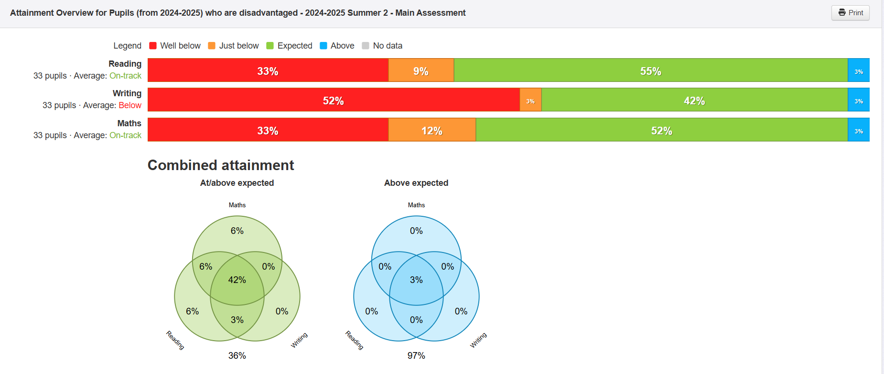
Tracking shows that this is impacted by the number of pupil premium children who are also SEND. Disadvantaged pupils without SEND, although below their non-disadvantaged peers, are more broadly in line in terms of outcomes. As a school we were also above national for number of EHCP children with complex needs.
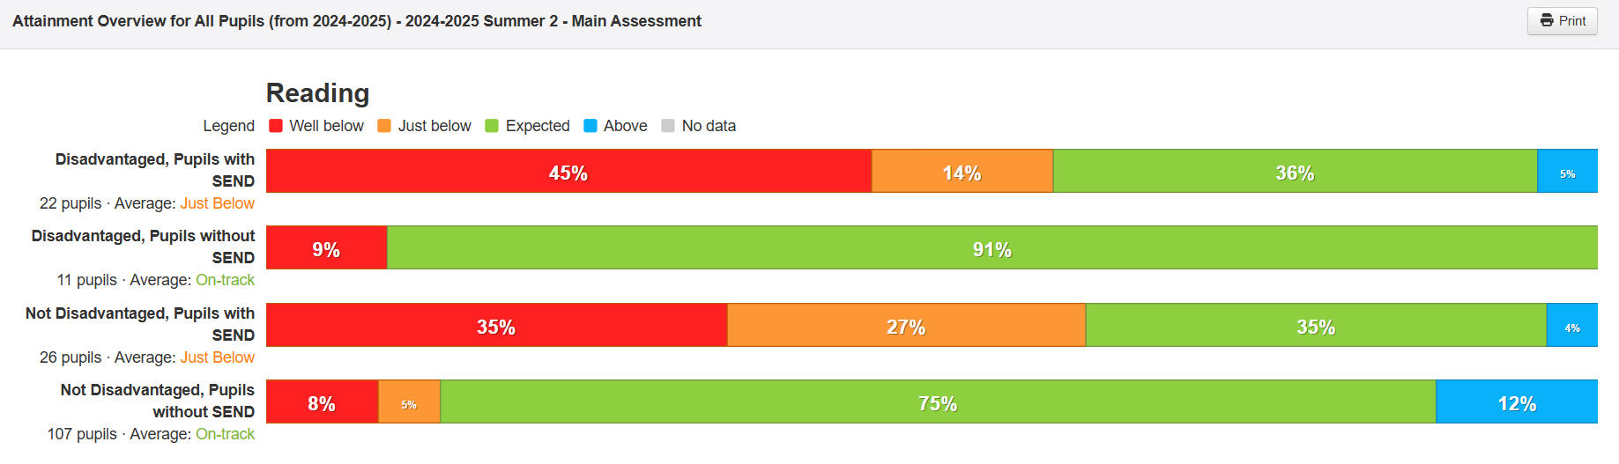
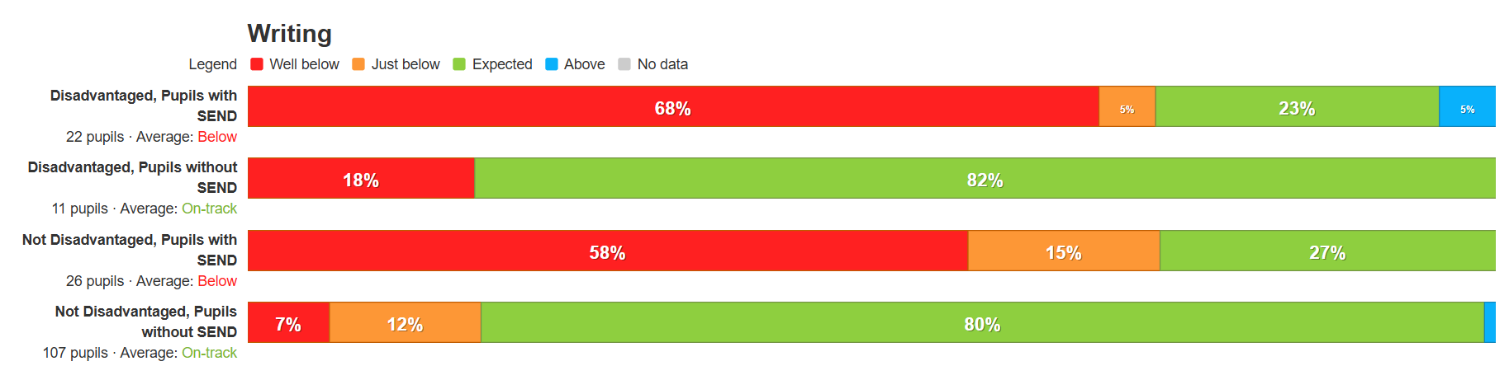
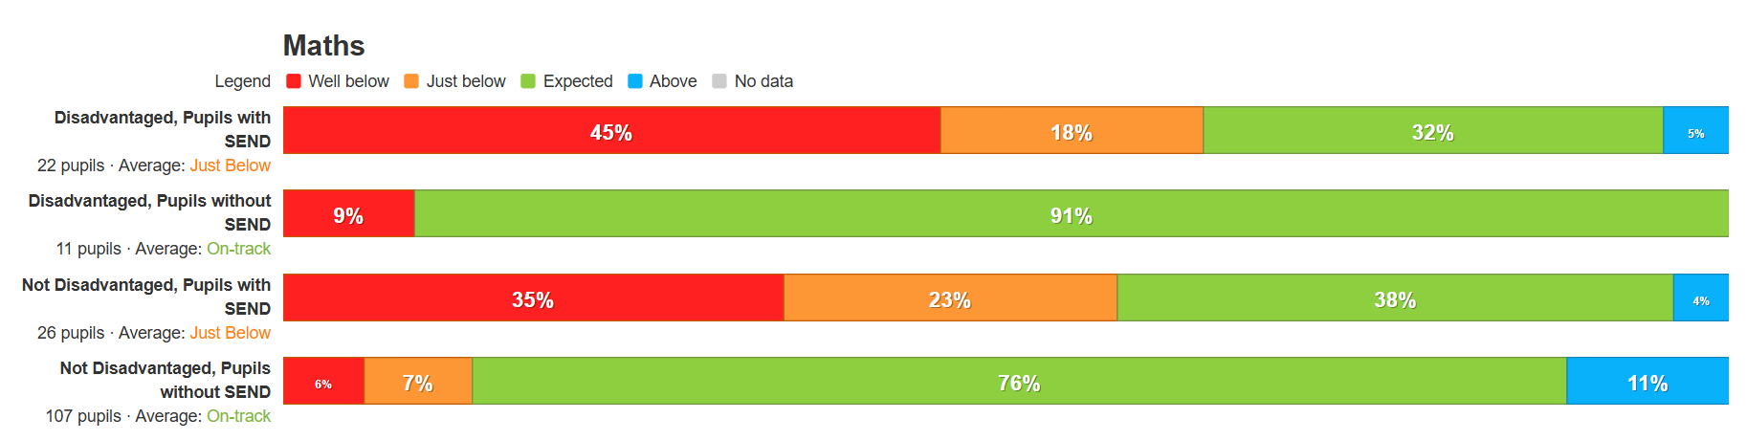
The correlation between disadvantaged and SEND pupils is also evident in current data, meaning ensuring we get provision correct for these children needs to be a continued focus. There continues to be a need to provide more targeted intervention and support for some individual pupils. The impact of speech and language and emotional literacy interventions have had a positive impact on pupils and so are a continued focus. Engagement with Voice 21 is a focus moving forward. This is particularly important with children joining us with low levels of communication skills at baseline.
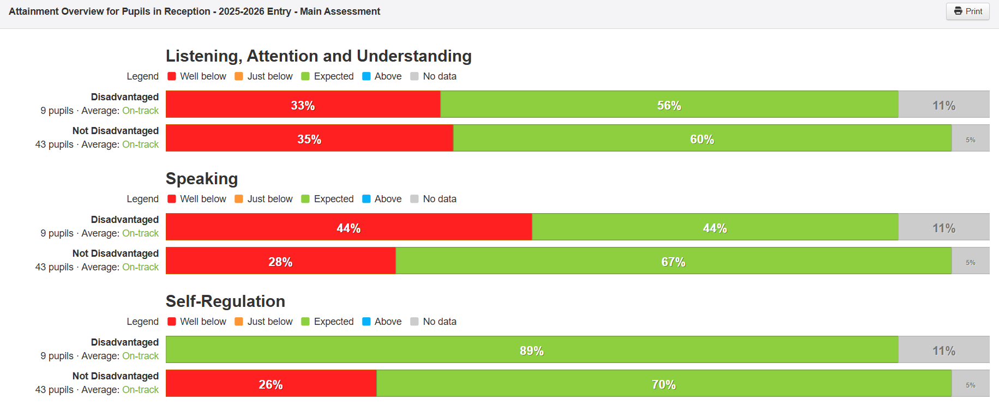

Externally provided programmes
Please include the names of any non-DfE programmes that you used your pupil premium to fund in the previous academic year.
Programme | Provider
None

