

Burnham on Sea Infant School
'Nurturing Minds, Growing Potential, Enriching Futures'

Behaviour Curriculum

2024-25

Overview of Content

 |  | Autumn 1 | Autumn 2 | Spring 1 | Spring 2 | Summer 1 | Summer 2
All Year |  | Explicit teaching | Ongoing revision | Longer recap of | Ongoing revision | Longer recap of | Ongoing revision of
Groups |  | of the full | of content | the behaviour | of content | the behaviour | content
From |  | behaviour |  | Curriculum |  | curriculum
EYFS |  | curriculum
to Y2 |  | Content  1-2 Weeks |  | Whole School Assembly |  | Whole School Assembly

Introduction

At Burnham On Sea Infant School, we develop children’s character through our Behaviour Curriculum. In order to build character, we define the behaviours and habits that we expect students to demonstrate. We want to support our pupils to grow from school ready children into adults who are polite, respectful, safe, and considerate of others. We believe that as pupils practise these behaviours, over time they become automatic routines that positively shape how they feel about themselves and how other people perceive them. In this way our school has a positive culture which enhances teaching, learning personal/social development and the opportunities we can offer our children. For this Behaviour Curriculum to be effective, it must be applied consistently by all member of staff in all school contexts. Everyone is responsible for modelling and managing behaviour throughout the school at all times. In adhering to our behaviour curriculum pupils can show how they are living the school values of being kind, curious and dedicated.

Teaching the curriculum

The curriculum is taught explicitly during the first two weeks in the autumn term alongside the traditional National Curriculum subjects. Children should learn the content of the curriculum so that they can recall the information and act upon it. At the start of each term, the Behaviour Curriculum is revisited with pupils in assemblies and in class. It will continue to be reinforced throughout the year. As with other curriculum content, this should be taught using explicit teaching based on the ten principles of instruction from Rosenshine, including regular quizzing to check and strengthen retention. This links to the school’s Approach to Pedagogy. Teachers will also demonstrate these behaviours and ensure pupils have time to practise these (particularly in the first few days of each term). For example, a lining up order should be taught in the classroom but must be reinforced in different locations and times throughout the school day e.g. at lunchtime. It is expected that all pupils will know this content. Understanding what a good model looks like is the key to creating long term recall.

Adaptations

While this curriculum is for all pupils it will be applied differently in different year groups depending on pupils’ ages and may be applied differently depending on individual pupils’ SEND needs. Any adjustments will be reasonable and detailed within specific individual plans. Sensitivity must be applied at all times when teaching the curriculum.
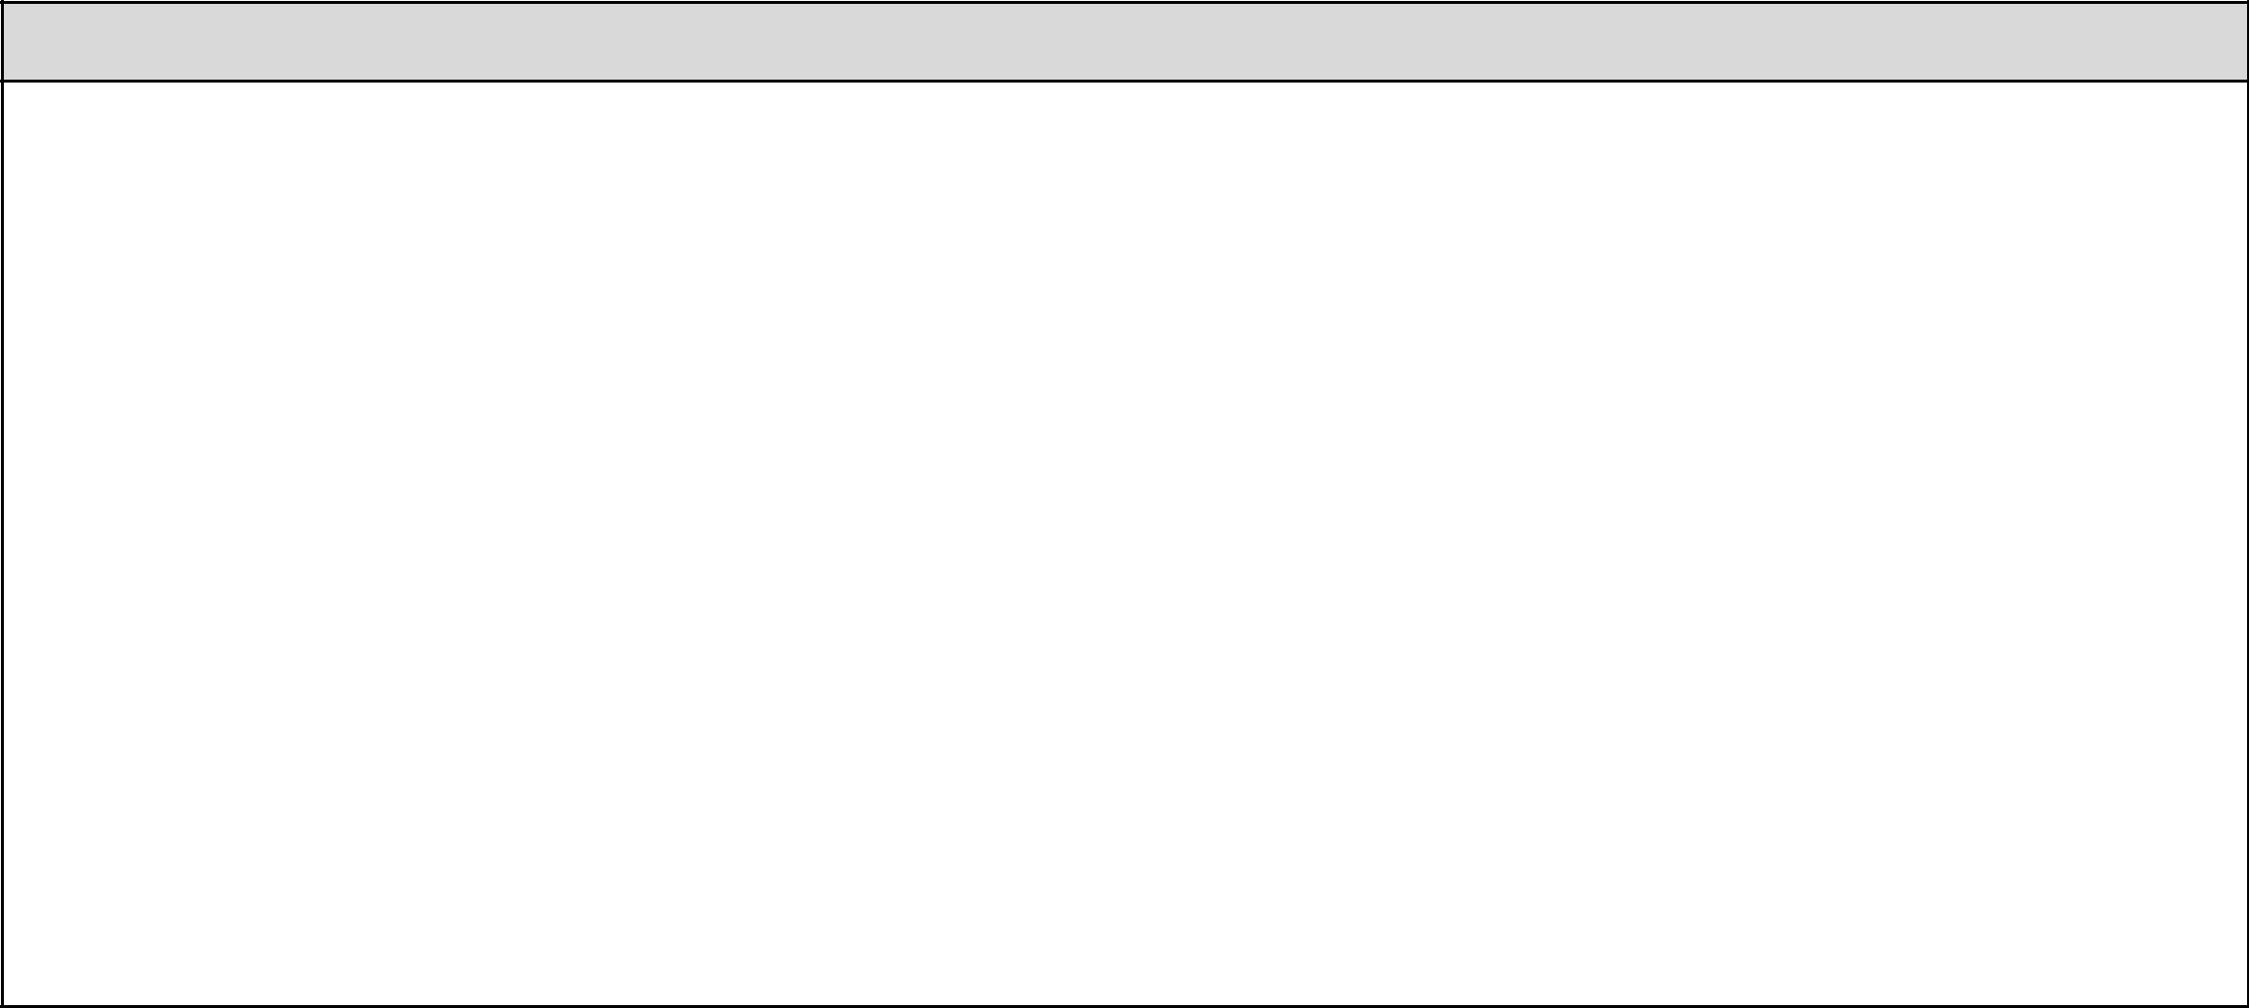
Curriculum Content

Curriculum content to be covered in depth in Autumn Term 1 and revisited throughout the year

Behaviour
Know that there are three behaviour expectations visible throughout the whole school. These are to
- be ready,

- be respectful,

- be safe,

Know the following examples of these three principles –
Be Respectful | Be Ready | Be Safe
Say please and thank you | Completing homework on time | Sitting sensibly in the classroom
Hold doors open for people | Remembering to bring equipment to | Walking through corridors
Talk kindly to other pupils | School eg PE kit, water bottle | Playing games that do not become too
Say good morning/ afternoon to adults | Wearing correct school uniform | physical.
Respect others right to learn  Respect school property by looking after it  Use a calm and polite tone of voice  Value differences  Follow staff instructions | Tidying up your own workspace and the classroom – ‘Choose it, Use it, Put it away’  Accepting responsibility if you make a mistake and saying sorry | Using calm and respectful tones when we communicate

Our routines:

Active Listeners Why? We all do active listeners to ensure everybody is able to learn without distractions. Know that pupils who do not follow school rules will have a consequence for this.

We use Active Listeners in class. Our staff use a signal to gain the attention of the class. This is done by clapping twice and twinkling fingers. When pupils see this, they should respond by being silent, twinkling fingers and responding with STAR.
S - Sitting or standing up straight
T - Tracking the teacher

A - Attention at all times

R - Respect towards others

Each classroom will have a display of the STAR for pupils to reference at all times.

Wonderful Walking
Why? We use Wonderful Walking to keep everyone safe in school and to make sure the learning of other children is not disrupted as people move around school.

We walk around school using Wonderful Walking
Wonderful Walking means -

•Facing forward
•Walking in a straight line
•Sensible hands
•Without talking
•Without leaning on walls whilst waiting

Careful contributing
Why? We use careful contributing to be given every chance to explore or discuss our learning and that we can be listened to ensuring my opinion is valued.

We expect all children to contribute in class. Careful contributing means:
- Listening to the class teacher or whoever is speaking

- Considering my responses before sharing

- Putting my hand up so I know my teacher knows I want to contribute during whole class discussions

- Sharing answers/contributions in a clear voice using full sentences

- Building on what others have said

Arriving at school at the beginning of the day
Why? We want to ensure that we are prepared for the day and we are in a calm and ready position for our learning.

- I arrive on time to school.
- I walk calmly to our classrooms.
- I greet staff with a smile and a ‘good morning’.
- I put my belongings away in the right places.
- I complete my Zones of Regulation check in.

- I show I am ready for learning.

Using good manners
Why? We want everyone to be kind and respectful to everyone at all times.

I should always say ‘please’ when I am asking for something.
I should always say ‘thank you’ when I receive something or someone does something nice for me.
I should say ‘Good morning/afternoon’ to adults if they have initiated the conversation.
It is important to show gratitude to others by thanking people for what they have done for me.
A calm and polite tone is respectful.
I should not talk when the teacher is delivering a lesson or another pupil has been asked to talk as this will stop myself and others from learning.

Playtime Behaviour
Why? We want everyone to feel happy and safe during playtime so that we can be friends and enjoy our own free time.

I must walk from my classroom to the playground using Wonderful Walking.
I must play safely without hurting anyone.
I do not ‘play fight’ because I may hurt someone by accident.
I must be kind, by including people in my games and sharing equipment.

Someone who is kind behaves in a gentle, caring, and helpful way towards other people.
When called, I must line up in my lining up order straight away.
I must walk back to my classroom using Wonderful Walking

Lunchtime
Why? We want everyone to enjoy their lunch in a peaceful and calm setting and that everyone contributes to a clean dining hall.

I use Wonderful Walking when walking to the hall.

I should use a normal talking volume when in the hall. I should not be raising my voice.
I should use a knife and fork correctly.

I use good manners by saying ‘please’ and ‘thank you’ when someone gives me my food or a drink.
I should not leave my seat once I have sat down.

Once I have finished, I raise my hand to let the staff know I have finished then I clear any rubbish from my table and empty any leftover food into the correct bin and walk outside.
I use wonderful walking when leaving the lunch hall

Completing work in books
Why? We want everyone’s book to be well presented and clear for anyone who wishes to read our learning. We want to respect our work, be proud of it and show it in the best way possible.

I should always work on the next available page unless told otherwise.
I should always write using my best handwriting.
In maths I should use one digit per box.
I correct mistakes by drawing a straight line through my work.
I stick anything in straight and centred on the page.

