
Burnham-on-Sea Infant School and
St Andrew’s Junior School, Burnham-on-Sea
Maths Calculations Policy
Updated November 2019
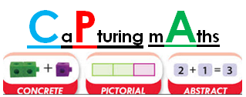
The following calculation policy been designed to teach children to develop conceptual understanding through the progression of concrete, pictorial and abstract methods and has been agreed by all staff at Burnham-on-Sea Infant School and St. Andrew’s Junior School. This policy meets the requirements of the National Curriculum 2014 for the teaching and learning of mathematics. It is also designed to give pupils a consistent and smooth progression of learning in calculations across the schools in line with the mastery approach. This calculation policy should be used to support children to develop a deep understanding of number and calculation.

Using the concrete-pictorial-abstract approach:
Children develop an understanding of a mathematical concept through the three steps (or representation) of concrete-pictorial-abstract approach. Reinforcement is achieved by going back and forth between these representations.
Concrete representation:
The enactive stage - a pupil is first introduced to an idea or a skill by acting it out with real objects. This is a 'hands on' component using real objects and it is the foundation for conceptual understanding.
Pictorial representation:
The iconic stage - a pupil has sufficiently understood the hands-on experiences performed and can now relate them to representations, such as a diagram or picture of the problem.
Abstract representation:
The symbolic stage - a pupil is now capable of representing problems by using mathematical notation, for example: 12 ÷ 2 = 6 .

Reception

Addition

Explore part part whole relationship
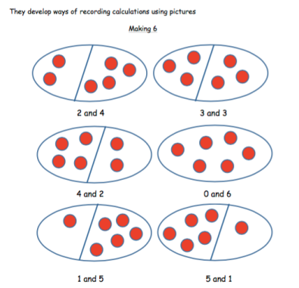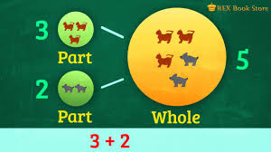
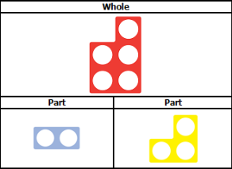

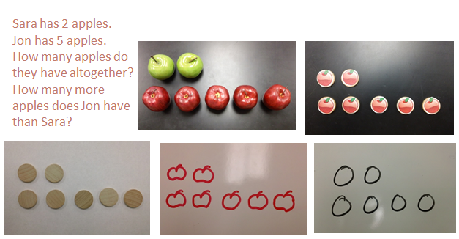
Using the ten frame to support addition of single digits – counting all/combining two groups
Solving problems using concrete and pictorial images.

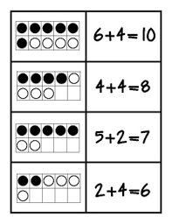

Subtraction

Peter has 5 pencils and 3 erasers. How many more pencils than erasers does he have?
Solving problems using concrete and pictorial images.

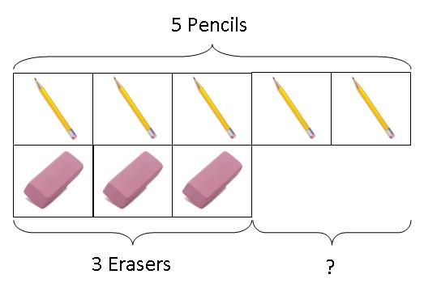

Using the ten frame to support subtraction by taking away

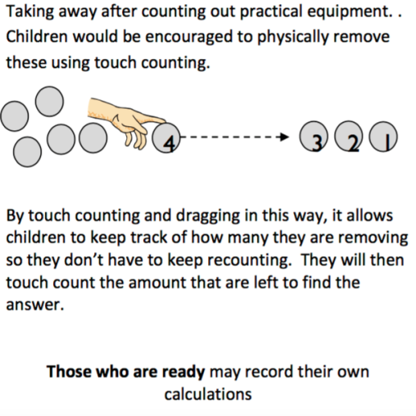
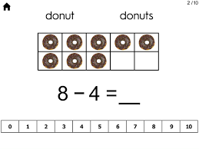

Multiplication

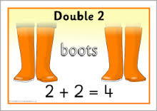

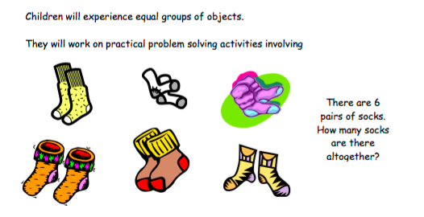
Division

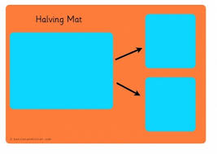
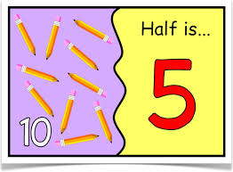

Year 1

Year 1 – Addition
Key Vocabulary
Part, whole, addition, add, forwards, put together, more than, total, altogether, distance between, difference between, equals = same as, most, pattern, odd, even, digit, counting on.
Combining two parts to make a whole
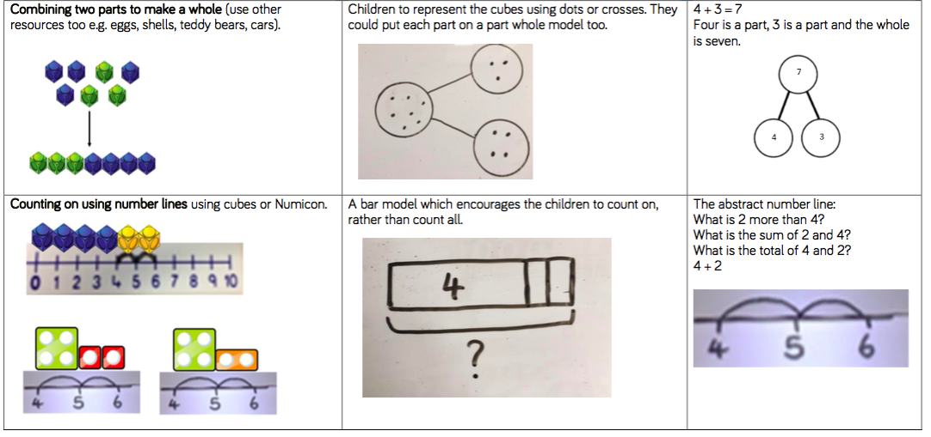
At its base level, addition is part-part-whole. The concept that when you add two different values, amounts, objects etc, the total amount you have is your whole. This can be expressed like this: part + part = whole. It can also be whole = part + part.
Counting on to find the total
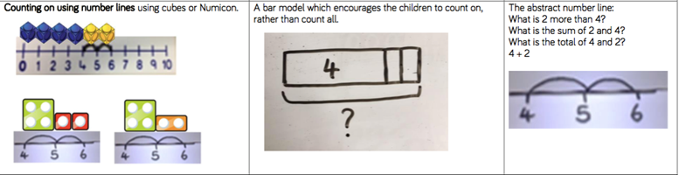
Children can also find the total of two, separate values by counting on using a =number line. This allows children to see the process of starting with zero, recognise this as an amount, and then build towards finding the whole.
Related facts (Inverse Operation) including number bonds to 20
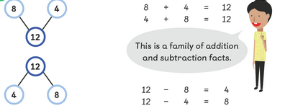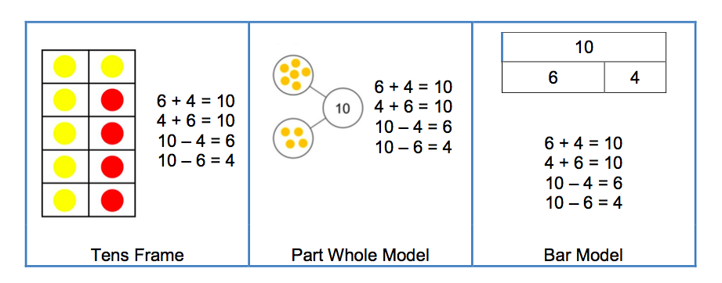
It is important that addition and subtraction are taught alongside each other as pupils need to see the relationship between the facts. Addition is the inverse (opposite method) of subtraction. Using the part-whole model, children can see that part + part = whole but also whole – part = part.
Regrouping to make 10
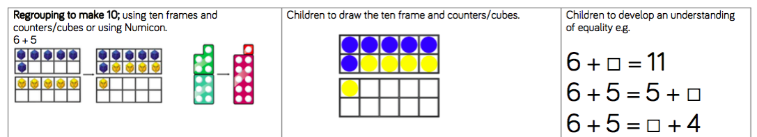
Using ten frames and related equipment, this will allow children to use their number bonds knowledge to partition numbers so they are easier to add. This is a mental calculation method that can be applied to larger numbers later on in the Key Stage.

Year 1 - Subtraction
Key Vocabulary
Part, whole, subtraction, subtract, take away, distance between, difference between, more than, minus, less than, equals = same as, most, least, pattern, odd, even, digit.
Physically taking away and removing objects from a whole
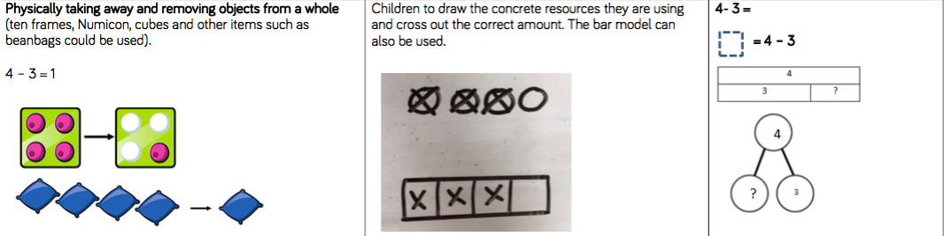
Children need to experience physically taking away and removing objects from a whole. By doing this, children will come to understand that subtraction makes a number, amount or total, smaller and you have fewer items or objects than you did before. This builds the conceptual understanding of what subtraction is. It is also important that children understand what you are left with is the difference.
Counting back
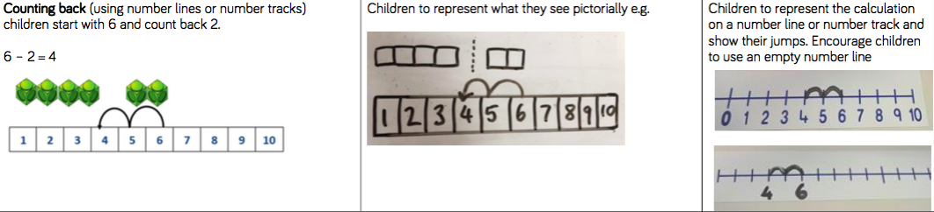
Counting back from the whole number to subtract can be an invaluable way for children to use their knowledge of the ordinality of number to find the answer. Numberlines, rulers or fingers can all be used here.

Finding the difference
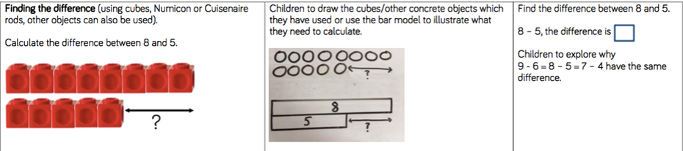
Children need to see the difference between two amounts before they can work this out in the abstract. When comparing two sets of objects the difference should be clear. Lots of different objects can be used here to enable children to see that finding the difference can be done with anything.
Making 10
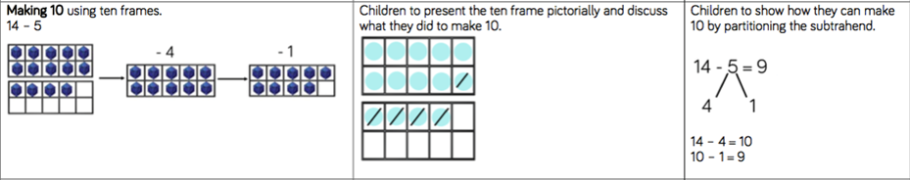
Much like counting back to subtract, making ten relies on children’s number bond knowledge and how to partition a number. This method works well when subtracting mentally.

Other ways to subtract
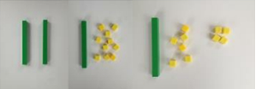
20 – 4 = 16
When subtracting using Dienes children should be taught to regroup a ten rod for 10 ones and then subtract from those ones. Again, this will test partitioning knowledge and how to make up a number in different ways.
Subtracting multiples of 10
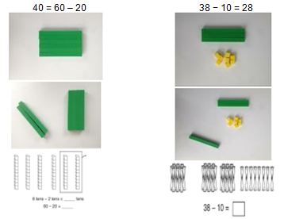
Using the vocabulary of 1 ten, 2 tens etc alongside 10, 20, 30 is very important here as pupils need to understand that it is a 10 not a 1 that is being taken away.

Year 1 – Multiplication
Key Vocabulary
Part, whole, ones, groups, lots of, doubling, repeated addition, groups of, lots of, times, columns, rows, longer, bigger, higher etc and times as (big, long, wide …etc)
Counting in multiples of 2, 5 and 10 from zero

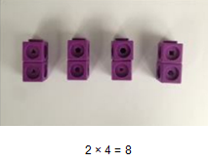
Children should count the number of groups on their fingers as they are skip counting.
4 groups of 2 = 8

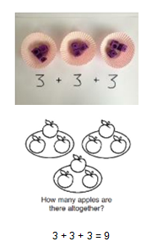
When moving to pictorial/written calculations the vocabulary is important:
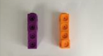
This image represents two groups of 4 or 4 twice Solving multiplication problems using repeated addition

Year 1 - Division
Key Vocabulary
Part, whole, share, share equally, one each, two each…, group, groups of, lots of, array
Sharing concrete resources practically
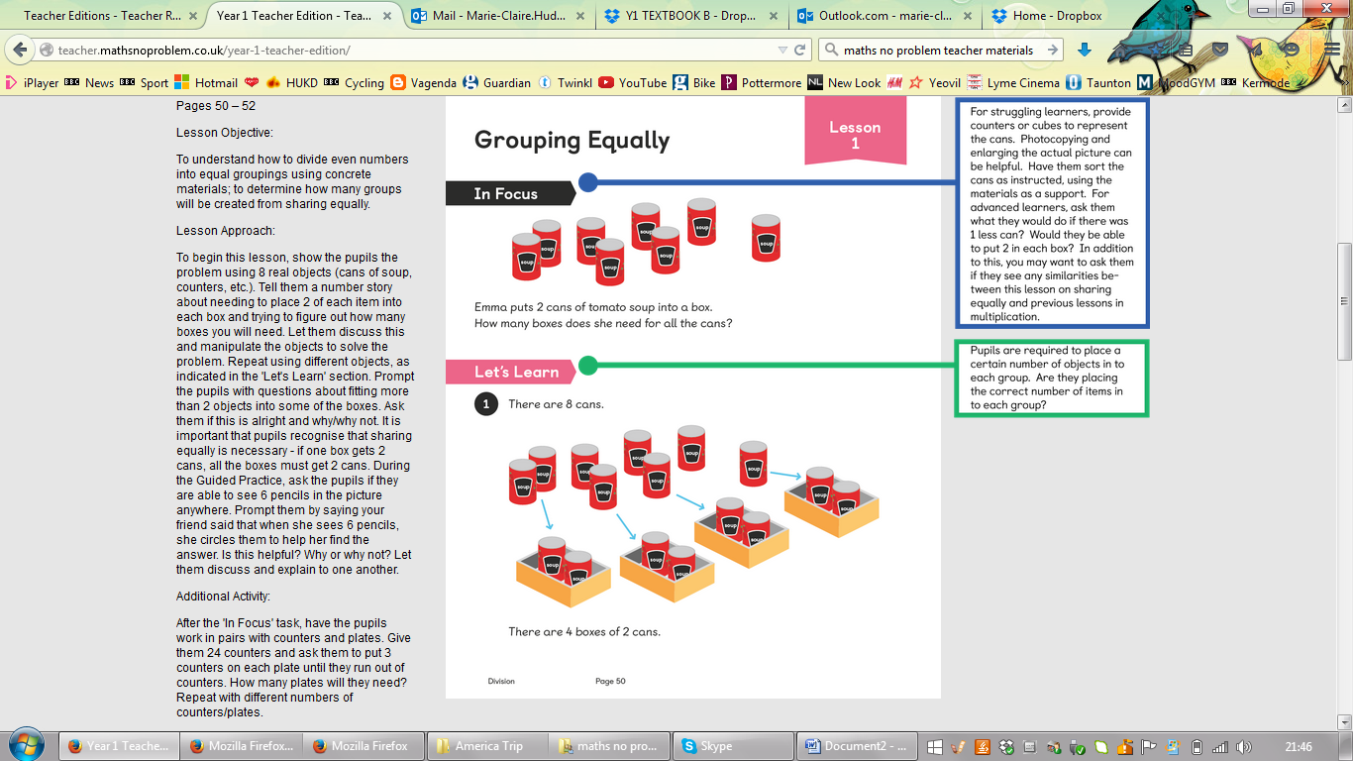
Pupils should be taught to divide through working practically and the sharing should be shown below the whole to familiarize children with the concept of the whole.
The language of whole and part part should be used.
8 ÷ 4 = 2
“I have 8 cans. This is my whole number. I want to share them between four boxes. Each box has 2 cans so each box has 2 parts.”

Year 2

Year 2 - Addition
Key Vocabulary
Part, whole, +, add, addition, more, plus, make, sum, total, altogether, how many more to make…? how many more is… than…? how much more is…? =, equals, sign, is the same as, tens, ones, partition, Near multiple of 10, tens boundary, more than, one more, two more… ten more…
Using concrete objects and pictorial representations to add 3 single digit numbers.
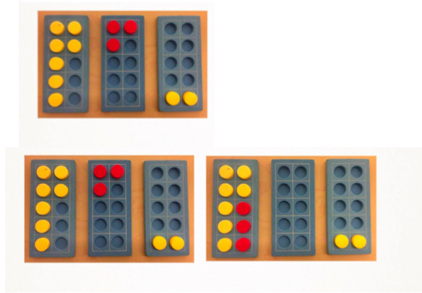
7+3+2 = leads to 10 + 2 =
By working with concrete resources, children need to be able to see where they can regroup to make 10. This will link to number bonds and how they can always look for 10.
Using concrete objects and pictorial representations to add a 2 digit number and ones and tens.
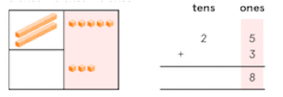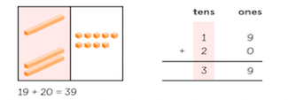
Understanding how each number is split into 10s and 1s will allow children to understand the method of addition conceptually before moving on to the written method.

Using concrete objects and pictorial representations to add two 2-digit numbers
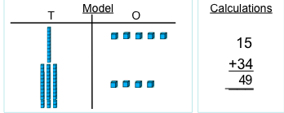
Understanding how each number is split into 10s and 1s will allow children to understand the method of addition conceptually before moving on to the written method.
Other ways to add
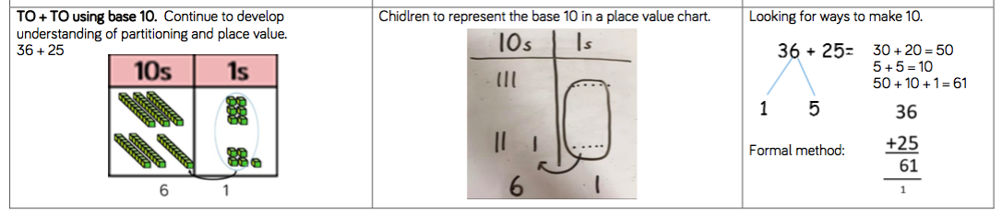
Using the bar to find missing digits
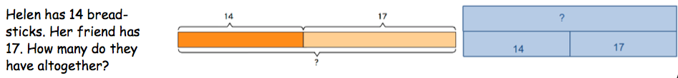
It is important for children to use the bar in this way to encourage the use of it to aid with problem solving. The link between part part whole should be made clear. The length of each part does not always have to be drawn to scale either.

Year 2 - Subtraction
Key Vocabulary
Part, whole, Subtraction, subtract, take away, difference, difference between, minus, tens, ones, partition, Near multiple of 10, tens boundary, Less than, one less, two less… ten less…
Using concrete objects and pictorial representations to subtract a 1-digit number from 2-digit number.
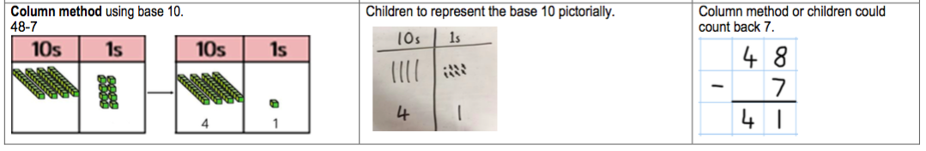
Building on the use of Dienes in year 1 to subtract ones from a 2-digit number, children will continue to make the link between subtraction making a whole number smaller.
Using concrete objects and pictorial representations to subtract a 10s number from 2 digit number.
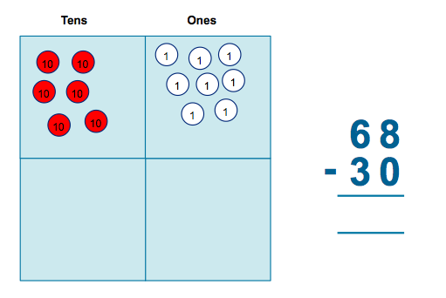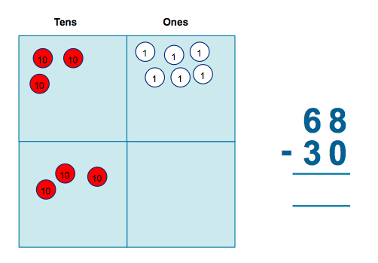
Children need the opportunity to see how taking away a 10s number from a 2-digit number does not affect the ones column. It is important to discuss why this might be the case. (A 10s number always ends in 0 …)
Using concrete objects and pictorial representations to subtract a 2-digit number from 2 digit number.
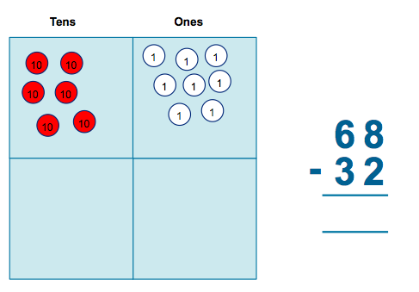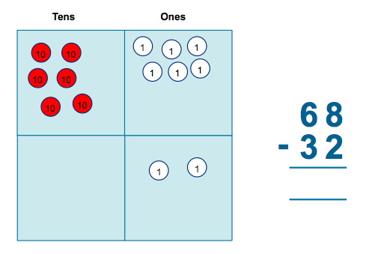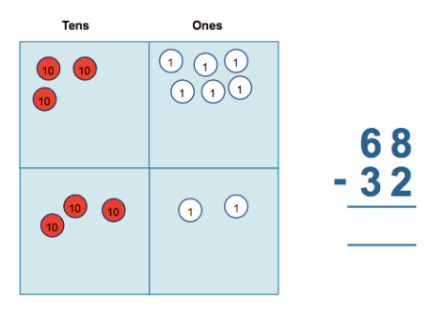
Children need to experience subtracting a 2-digit number from a 2-digit number without having to exchange and regroup.
As above but at Greater Depth:
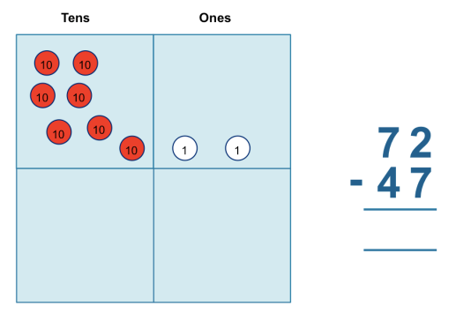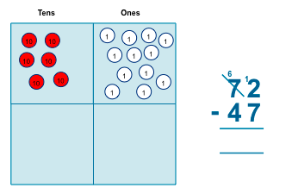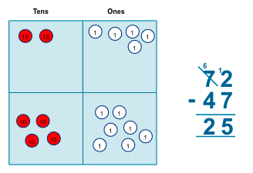
Children working at greater depth will need to experience using concrete resources and having to exchange in order to solve the calculation.
Recognise and use the inverse relationship between addition and subtraction
?
23 | 53

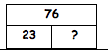
Children should use this to check inverse calculations. This can be used to reason and prove that they are correct. Using the bars, children need to make the link between part-part-whole.

Year 2 - Multiplication
Key Vocabulary
Part, whole, multiple, multiplication array, multiplication tables / facts, groups of, lots of, times, columns, rows
Skip counting in multiples of 2, 3, 5, 10 from 0
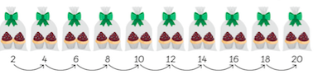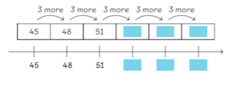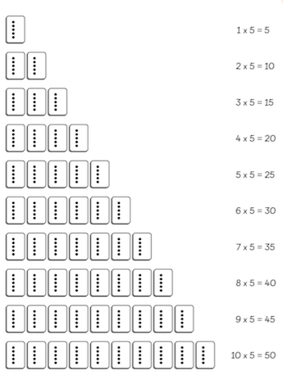
Children need to recall and use multiplication facts for the multiplication tables 2, 5 and 10. Through skip counting with different objects, children need to develop an understanding of how groups of items get larger with each jump and the idea of the whole.
Repeated grouping / repeated addition
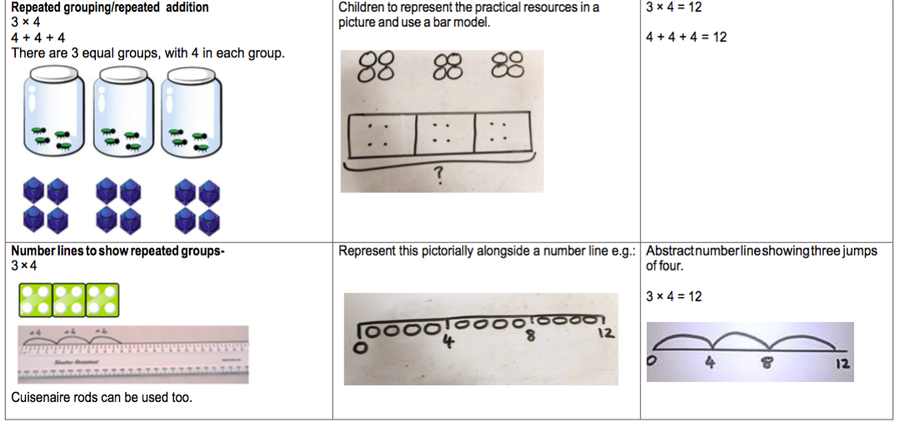
With repeated grouping, children can build their understanding of how multiplication increases a whole amount.

Commutativity
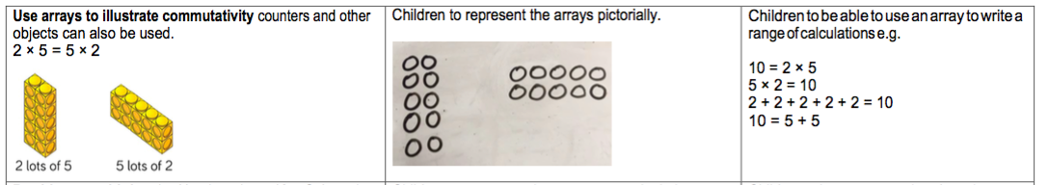
Children need introducing to the concept of commutativity. The idea what multiplication can be calculated either way around. The answer will be the same. Addition is also commutative. Arrays are the best way to explore this concept in the initial instance.

Year 2 - Division
Key Vocabulary
Part, whole, group in pairs, 3s … 10s etc, equal groups of, divide, ÷, divided by, divided into, remainder
Sharing into equal groups
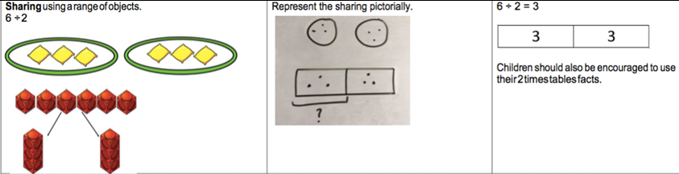
Using concrete resources, children can group objects to share them equally. Links can be made between multiplication and how the times tables facts relate to groups of. Children should also be made aware that multiplication and division are inverse operations.
Repeated Subtraction
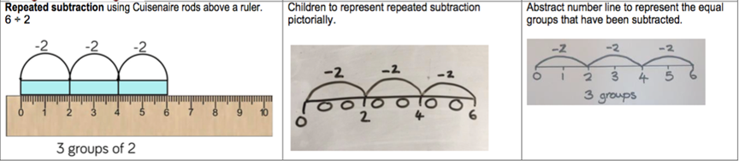
Repeated subtraction allows children to use the ordinality of number to share objects equally. Again, this method could then be proved using multiplication statements.

Solve division problems in context by:
Using arrays
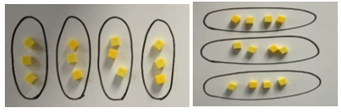
Division as grouping
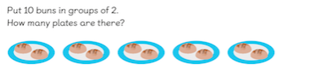
Once children have a firm understanding of division as sharing amounts equally, they should be introduced to solving problems in context. Using arrays ensures that children make the link between multiplication and division.
As above but working at Greater Depth with remainders
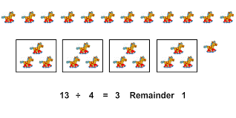
To extend children’s understanding and deepen their knowledge of division, children working at greater depth should be introduced to division including remainders. They should recognise that a remainder is worth something.

Year 3
Year 3 – Addition
Key Vocabulary
Part, whole, hundreds, tens, ones, estimate, partition, recombine, difference, decrease, near multiple of 10 and 100, inverse, rounding, column subtraction, exchange - See also Y1 and Y2
Add two three-digit numbers
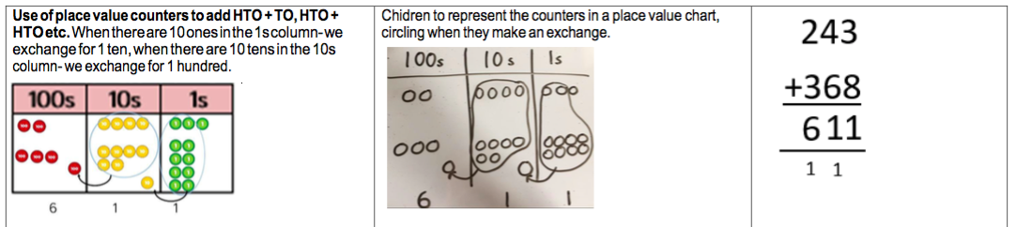
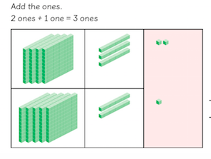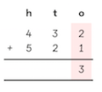
Children need to use equipment first to support their understanding of place value. Children to progress gradually to three digit + three digit starting without carrying and gradually moving towards carrying.

Using the bar to find missing digits
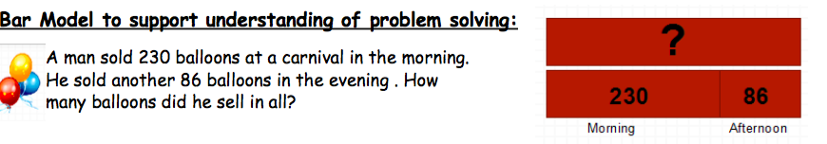
It is important for children to use the bar in this way to encourage the use of it to aid with problem solving. The bar is a great way for children to pictorially record and visualise what a problem is asking.

Year 3 - Subtraction
Key Vocabulary
Part, whole, hundreds, tens, ones, estimate, partition, recombine, difference, decrease, near multiple of 10 and 100, inverse, rounding, column subtraction, exchange
See also Y1 and Y2
Subtract up to 3 digits from 3 digits
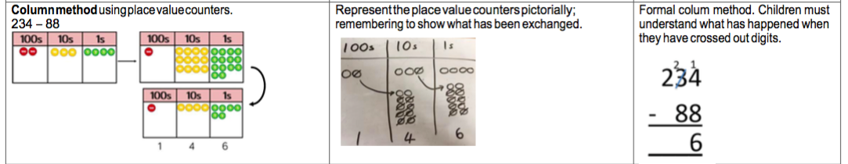
It is very important for children to use dienes equipment along with a place value chart to support. Only when secure with the method should exchanging be introduced. Place value counters are imperative here.
Using the bar to find missing digits
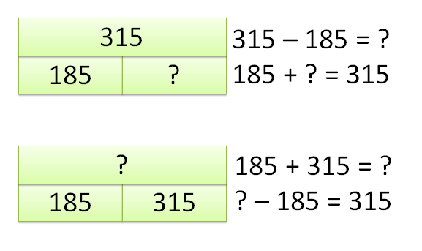
It is important for children to use the bar in this way to encourage the use of it to aid with problem solving. The bar is a great way for children to pictorially record and visualise what a problem is asking.
Year 3 – Multiplication
Key Vocabulary
Part, whole, multiple, partition, short multiplication and inverse
Multiply a two-digit number by a one digit
Children should be able to recall the 2, 5, 10, 3, 4 and 8 times tables.
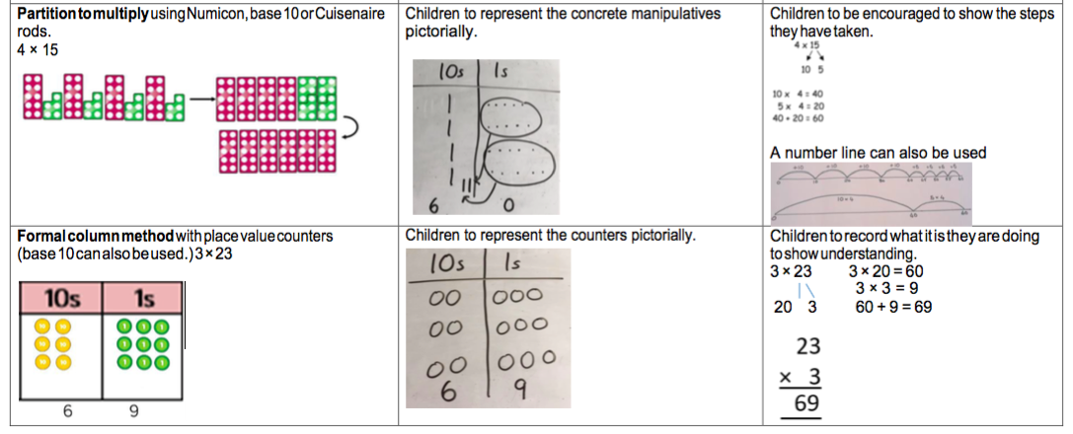
Being able to partition a number when multiplying and being able to visualise it correctly will aid mental calculation later on in a child’s learning.
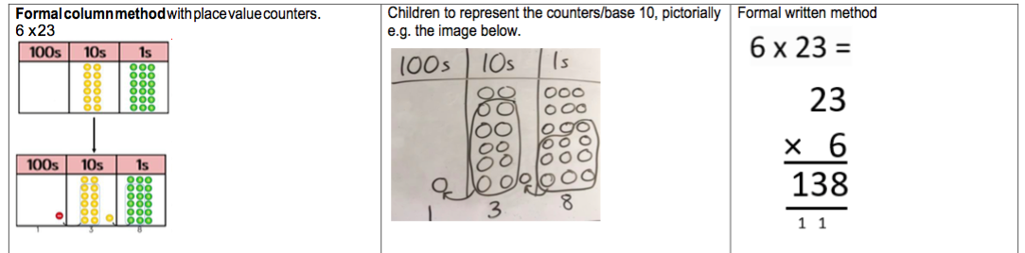
As children become more confident with multiplying a one digit number by a one digit number, lining up the counters will allow children to understand that multiplication is groups of something and how it increases. This will lend itself to understanding that division is the inverse operation.

Using the bar to solve multiplication problems
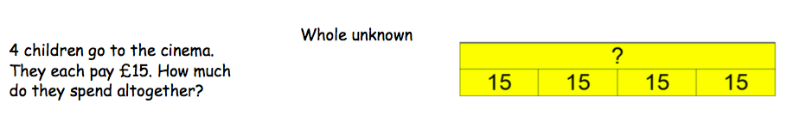
It is important for children to use the bar in this way to encourage the use of it to aid with problem solving. The bar is a great way for children to pictorially record and visualise what a problem is asking.

Year 3 - Division
Key Vocabulary
Part, whole, See Y1 and Y2 and Inverse, remainder
Short division
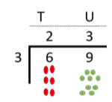
Remind children of correct place value, that 69 is equal to 60 and 9, but in short division, pose:
· How many 3’s in 6? = 2, and record it above the 6 tens.
· How many 3’s in 9? = 3, and record it above the 9 ones.
Sharing using place value counters (including carrying remainders within the division)
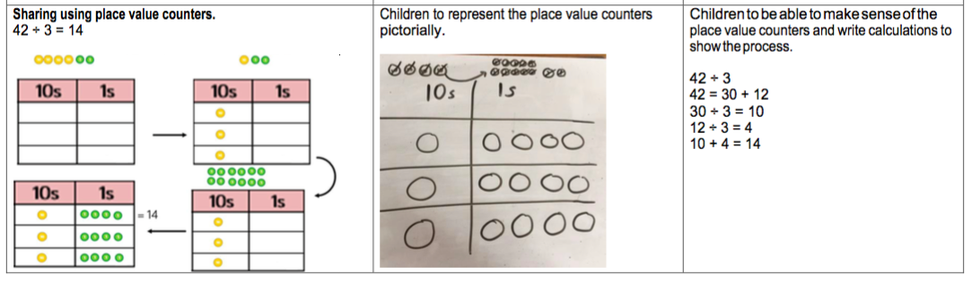
Once children demonstrate a full understanding of remainders, and also the short division method taught, they can be taught how to use the method when remainders occur within the calculation (e.g. 42÷3), and be taught to ‘carry’ the remainder onto the next digit.

Using the bar to aid the solving of division problems – grouping and sharing
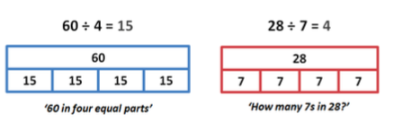
It is important for children to use the bar in this way to encourage the use of it to aid with problem solving. The bar is a great way for children to pictorially record and visualise what a problem is asking.

Year 4
Year 4 – Addition
Key Vocabulary
Part, whole, add, addition, sum, more, plus, increase, sum, total, altogether, double, near double, how many more to make..? how much more? Ones boundary, tens boundary, hundreds boundary, thousands boundary, tenths boundary, hundredths boundary, inverse, how many more/fewer? Equals sign, is the same as.
Adding numbers with up to 4 digits
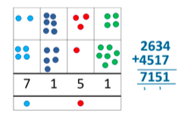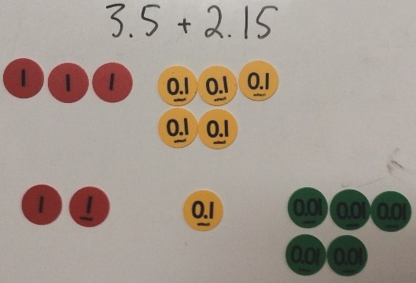
Again this should start with the children using dienes to support them with lots of discussion about the value of each digit. Once children are ready they should be encouraged to pictorially represent the numbers they are adding. Children should have a firm understanding of how to partition the numbers and should be able to explain the value of each digit.
Using the bar to find missing digits
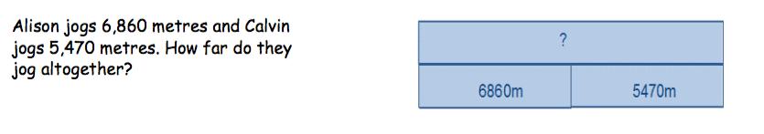
It is important for children to use the bar in this way to encourage the use of it to aid with problem solving.
This is not a form of getting the correct answer but helping to guide children to the correct operation.

Year 4 – Subtraction
Key Vocabulary
Part, whole, subtract, takeaway, less, minus, decrease, fewer, difference, how many less to make..? how much less? ones boundary, tens boundary, hundreds boundary, thousands boundary, tenths boundary, hundredths boundary, inverse, how many fewer? Equals sign, is the same as.
To subtract with numbers up to four digits (including exchanging when children are secure)
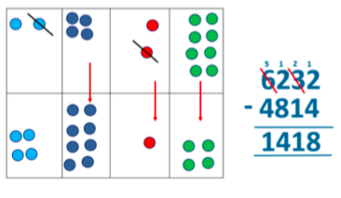
Children need to use place value counters to support their learning. All children should be able to understand what actually happens when they exchange and carry across a subtraction. Working out a problem one step at a time and vocalising the method should be encouraged.
Using the bar to find missing digits
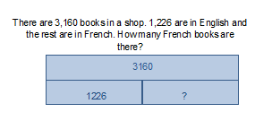
It is important for children to use the bar in this way to encourage the use of it to aid with problem solving. The bar is a great way for children to pictorially record and visualise what a problem is asking.

Year 4 - Multiplication
Vocabulary
Part, whole, Factor, product
Multiplying both two and three digits by a one digit number using place value counters
Children to know all times tables to 12 x 12
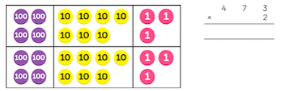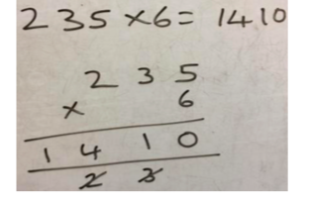
Expanded multiplication using place value counters in instrumental in children understanding the place value of each digit as they multiply them together. It will aid overall understanding that by multiplying a number makes it bigger.
Multiplying using the bar
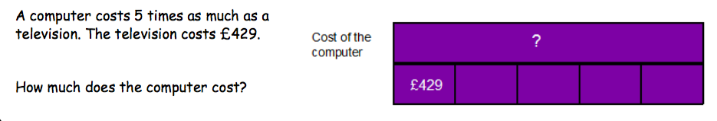
It is important for children to use the bar in this way to encourage the use of it to aid with problem solving. The bar is a great way for children to pictorially record and visualise what a problem is asking.

Year 4 - Division
Key Vocabulary
Part, whole, see years 1-3, divide, divided by, divisible by, divided into, share between, groups of, factor, factor pair, multiple, times as (big, long, wide …etc), equals, remainder, quotient, divisor and inverse
Dividing up to three digit numbers by a one digit number using short division
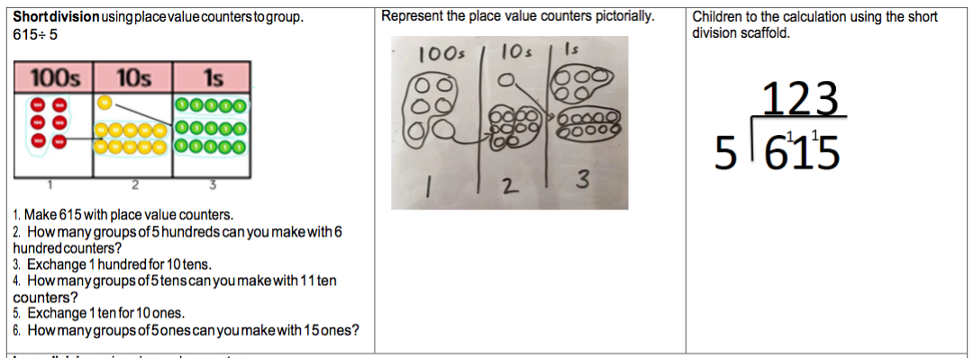
Only when the children are secure with dividing a two digit number should they move onto a 3 digit number. When children are working through the division using counters, they should be shown the written method side-by-side. This will aid their understanding of how the two are connected and what it actually happening when they write the numbers above a short division written method.
Dividing up to three digit numbers by a one digit number using short division with remainders
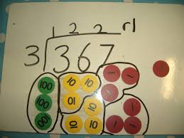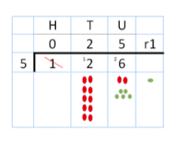
When children are secure, they should be encouraged to recognise that a remainder is relevant and needs to be counted as part of the answer.

Dividing using the bar
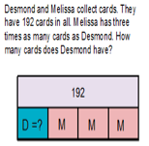
It is important for children to use the bar in this way to encourage the use of it to aid with problem solving. The bar is a great way for children to pictorially record and visualise what a problem is asking.

Year 5
Year 5 - Addition
Key Vocabulary
Part, whole, tens of thousands boundary - Also see previous years
Adding numbers with more than 4 digits including decimals
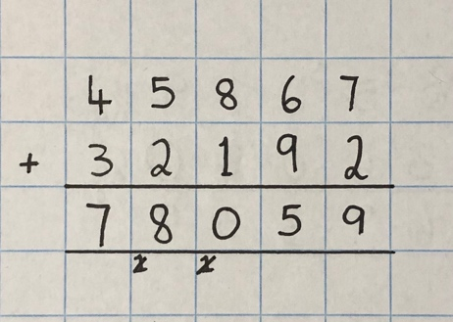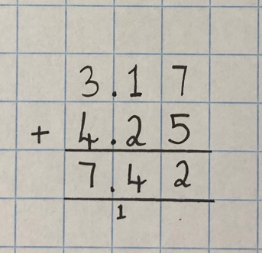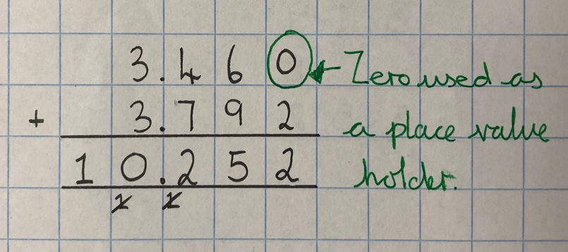
Using place value charts are key to this as well as place value counters to help with the decimals. Children should be able to explain the value of each digit and make links between greater than and less than. Children should also be encouraged to relate the written method back to part-part-whole.
Using the bar to find missing digits
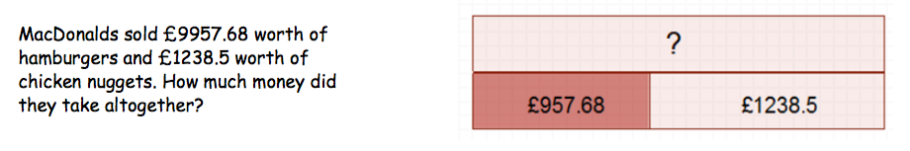
It is important for children to use the bar in this way to encourage the use of it to aid with problem solving.
This is not a form of getting the correct answer but helping to guide children to the correct operation.

Year 5 - Subtraction
Key Vocabulary
Part, whole, tens of thousands boundary,
Also see previous years
Subtract with at least four digit numbers including two decimal places
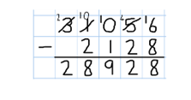
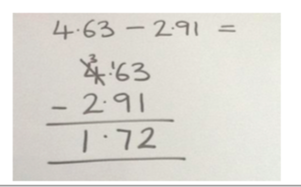
Include money, measures and decimals ensuring that children do this practically before the abstract. Understanding the value of money and how it related to the place value of a calculation is important. Subtract with decimal values, including mixtures of integers and decimals, aligning the decimal point.
Using the bar to find missing digits
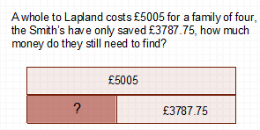
It is important for children to use the bar in this way to encourage the use of it to aid with problem solving. The bar is a great way for children to pictorially record and visualise what a problem is asking.

Year 5 - Multiplication
Key Vocabulary
Part, whole, cube numbers, prime numbers, square numbers, common factors, prime number, prime factors and composite numbers
Multiplying up to four digit numbers by two digits using long multiplication
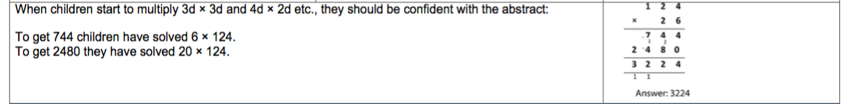
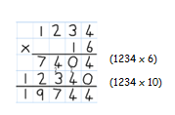
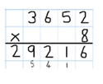
Children need to be taught to approximate first, e.g. for 72 x 38, they will use rounding: 72 x 38 is approximately 70 x 40 = 2800, and use the approximation to check the reasonableness of their answer.
Using the bar to support multiplication
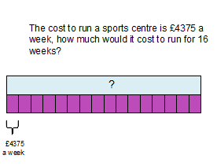
It is important for children to use the bar in this way to encourage the use of it to aid with problem solving. The bar is a great way for children to pictorially record and visualise what a problem is asking.

Year 5 - Division
Key Vocabulary
Part, whole, common factors, prime number, prime factors, composite numbers, short division, square number, cube number, inverse, power of. Also see year 4
Diving with up to four digit numbers by one digit including numbers where remainders are left
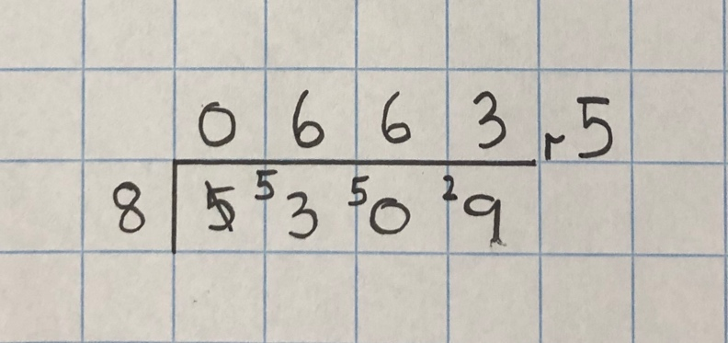
Short division with remainders: Now that pupils are introduced to examples that give rise to remainder answers, division needs to have a real life problem solving context, where pupils consider the meaning of the remainder and how to express it, ie. as a fraction, a decimal, or as a rounded number or value , depending upon the context of the problem.
Using the bar to support division problems
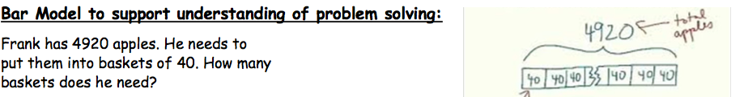
It is important for children to use the bar in this way to encourage the use of it to aid with problem solving. The bar is a great way for children to pictorially record and visualise what a problem is asking.

Year 6
Year 6 - Addition
Key Vocabulary
Part, whole, See all previous years
Adding several numbers with up to three decimal places
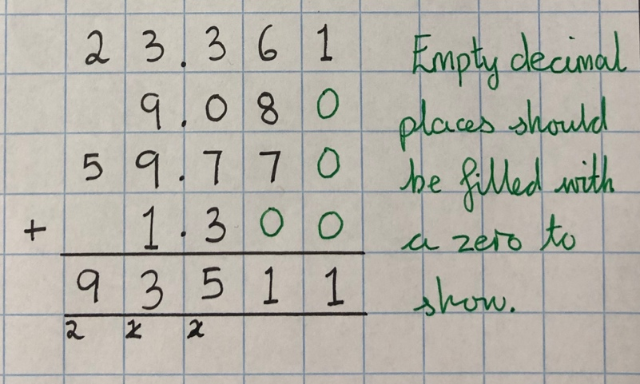
It is important that children can identify the place value of a range of numbers and line them up correctly in order to solve an addition of mixed values. This could include money, measures, decimals etc.
Adding using the bar
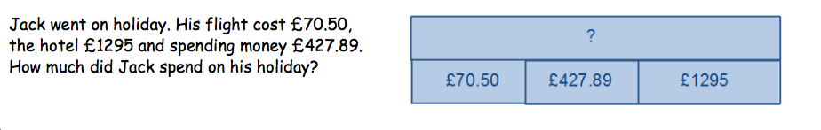
It is important for children to use the bar in this way to encourage the use of it to aid with problem solving. The bar is a great way for children to pictorially record and visualise what a problem is asking.

Year 6 - Subtraction
Key Vocabulary
Part, whole, See previous years
Subtracting with increasingly large and more complex numbers and decimal values
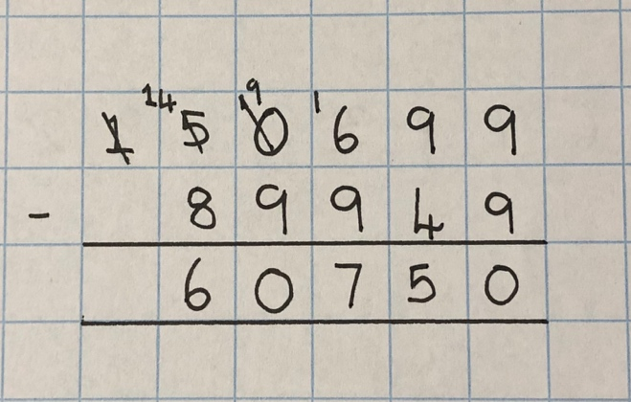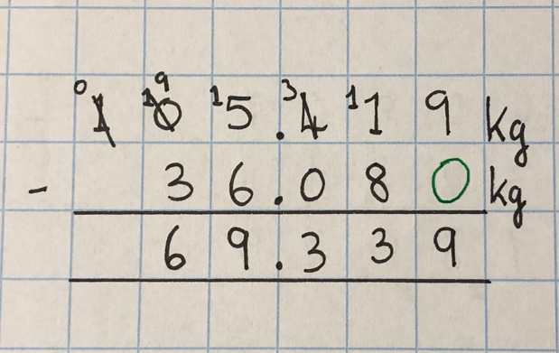
It is important that children can identify the place value of a range of numbers and line them up correctly in order to solve an subtraction of mixed values. This could include money, measures, decimals etc.
Using the bar for subtraction
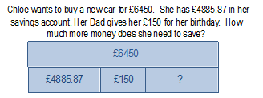
It is important for children to use the bar in this way to encourage the use of it to aid with problem solving. The bar is a great way for children to pictorially record and visualise what a problem is asking.
Year 6 - Multiplication
Key Vocabulary
Part, whole, common factors, See previous years
Short and long multiplication with up to two decimal places
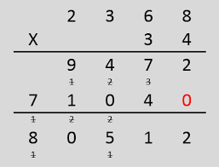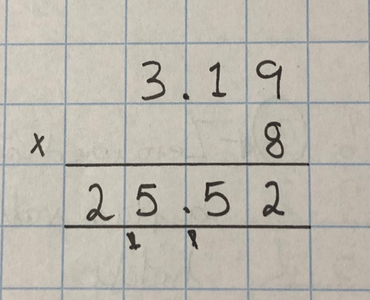
Children need to be exposed to a wide range of multiplication problems including up to 2 decimal places.
Using the bar for multiplication
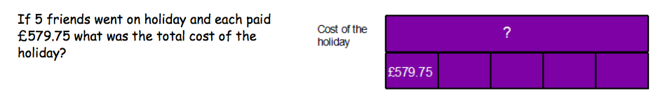
It is important for children to use the bar in this way to encourage the use of it to aid with problem solving. The bar is a great way for children to pictorially record and visualise what a problem is asking.

Year 6 - Division
Key Vocabulary
Part, whole, long division, See years 4 and 5
Divide at least 4 digits by both single-digit and 2-digit numbers (including decimal numbers and quantities)
Short Division (including remainders)
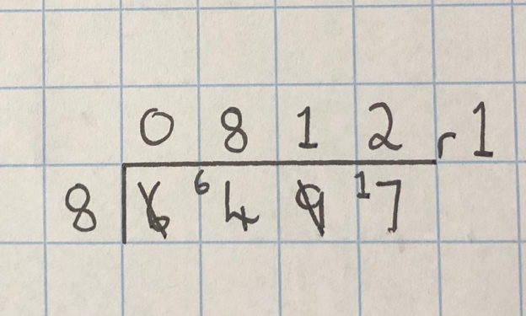
Short division with remainders: Pupils should continue to use this method, but with numbers to at least 4 digits, and understand how to express remainders as fractions, decimals, whole number remainders, or rounded numbers. Real life problem solving contexts need to be the starting point, where pupils have to consider the most appropriate way to express the remainder.
Long Division using factors
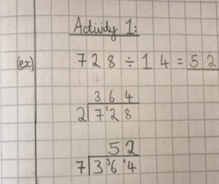
Children should be introduced to long division and dividing by 2 digits through using factors. This will allow children to deepen and extend their understanding of how a division can be solved in different ways. This will only work if the divisor is not a prime number.
Long Division using skeleton tables
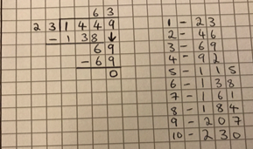
Children should be introduced to long division and dividing by 2 digits through using skeleton tables. This method will allow children to estimate an answer using their times tables before they solve the method properly.
Using the bar for division
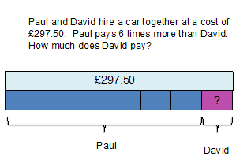
It is important for children to use the bar in this way to encourage the use of it to aid with problem solving. The bar is a great way for children to pictorially record and visualise what a problem is asking.

