
Burnham-on-Sea Infant School
'Nurturing Minds, Growing Potential, Enriching Futures'

Computing Curriculum Overview
Curriculum Lead: Tim Richards

‘Coding is like solving puzzles with your imagination. In the world of computers, your imagination has no limits.’

Intent (curriculum design, coverage and appropriateness):
All children at Burnham-on-Sea Infant School have the right to rich, deep learning experience to obtain a broad range of computing skills through a variety of digital experiences. To provide opportunities for children to use and experience technology confidently, safely and responsibly; ensuring our children are on the journey to go into the world digitally literate and prepared for the significant role that technology plays in society today.

Implementation (curriculum delivery, teaching and assessment):
At Burnham-on-Sea Infants we enable children to understand and apply concepts of computing through the following four main areas: programming, technology around us, creating media and data and information. These areas also run alongside online safety. As well as this, computing is deeply linked with other areas of the curriculum and is embedded throughout the school.
Computing is taught in an engaging and inclusive way through a clear and effective scheme of work, Teach Computing (KS1), that provides coverage that is in line with the national curriculum. Children have access to a wide range of digital devices throughout their school journey at Burnham Infants.
The journey begins for Early Years Foundation Stage, by listening to a broad selection of stories which will help foster their understanding of out technologically diverse world, and practical exploration through child-initiated play. Alongside the core lessons, children are also taught how to use technology safely, following advice provided by trusted adults. This instruction is supported by the Project Evolve materials, which offer guidance on responsible digital behaviour and online safety. These resources help children develop a strong understanding of how to navigate the digital world securely and responsibly, empowering them to make informed choices while using technology.
In Key stage 1, children are taught the first steps of computer programming, recognizing how technology is used in their environment, presenting information and how to present the data they have collected. This is taught through the Teach Computing materials. It is a spiralized curriculum where each of the themes are revisited regularly (at least once a year), and pupils revisit each theme through a new unit that consolidates and builds on prior learning within that theme. Each lesson is sequenced so that it builds on the learning from the previous lesson. Exploratory tasks foster a deep understanding of a concept, encouraging pupils to apply their learning in different contexts and make connections with other learning experiences.
As part of our Computing Curriculum, we use a comprehensive scheme of work to teach aspects of Online Safety explicitly throughout the year. Project Evolve is an online based scheme of work which is constantly 'evolving' to ensure the online safety messages that children and young people are being taught are delivered in a way that is more appropriate; more meaningful; that encourages reflection; that generates positive outcomes and are updated regularly to reflect the changing world.

Online Safety content is separated into eight strands which are taught throughout the year covering everything from self-image and identity, online relationships, online reputation, online bullying, managing online information, Health Wellbeing and lifestyle, privacy and security to copyright and ownership.
Since we value our school’s understanding of online safety so highly, we believe that the teaching of online safety should not be limited to discreet lessons. We ensure that this topic is frequently approached in lots of different ways. Whole school assemblies and class discussions promote pupil voice, we take part in national events such as Safer Internet Day. Our online safety efforts are monitored regularly using the 360 safe self-assessment tool.
Lessons are taught on a weekly basis, with the specific content depending on the unit being covered at that time. This structure allows for flexibility in addressing the key objectives of each unit, ensuring that lessons can be adapted to meet the needs of the students and the subject matter. The weekly format provides consistency while allowing for a focused exploration of each topic, ensuring depth of understanding over time. All lessons have clear objectives, which are achieved through clear and engaging activities. All children have access to the technology across the school and technology to support their learning. Lessons promote the development of safe and appropriate long-term behaviours, whilst also supporting children and staff in shaping the culture at Burnham-on-Sea Infants and beyond.
Impact (attainment and progress):
Children will be confident and competent users of technology. They will be creative thinkers when using technology to present, record, share and solve problems. By the end of Year 2 they will be responsible, respectful and safe users of information and communication technology. They will have an awareness of technological uses and developments in the wider world.

The Computing lead at Burnham-on-Sea will;
- Help design the curriculum map and then to monitor to ensure that units are being taught at the correct time.
- Complete learning walks, speak to pupils about their learning and discuss with colleagues successes and barriers.
- Available to offer subject knowledge and advice when needed to support teaching staff in their understanding and delivery of both computing and online safety curriculum.
- Engage with CPD opportunities

Computing Curriculum Overview
Computing at Key Stage 1
The Key Stage 1 National Curriculum for Computing identifies that children should be taught to:  - understand what algorithms are; how they are implemented as programs on digital devices; and that programs execute by following precise and unambiguous instructions  - create and debug simple programs  - use logical reasoning to predict the behaviour of simple programs  - use technology purposefully to create, organise, store, manipulate and retrieve digital content  - recognise common uses of information technology beyond school  - use technology safely and respectfully, keeping personal information private; identify where to go for help and support when they have concerns about content or contact on the internet or other online technologies. |  |  |  | How we teach computing:  As a school we follow the teach computing curriculum for years 1 and 2. Teach computing is a spiral curriculum with four main themes running through; Computing systems and networks, creating media, programming and data and information.  Each unit of work the concepts will be discussed, learnt about and integrated into both plugged and unplugged lessons.
 | Autumn 1 | Autumn 2 | Spring 1 |  | Spring 2 | Summer 1 | Summer 2
 | Computing Systems and networks | Creating Media | Programming A |  | Data and Information | Creating Media | Programming B
Year 1 | Technology around us  Recognising technology in school and using it responsibly | Digital painting  Choosing appropriate tools in a program to create art, and making comparisons with working non-digitally. | Moving a robot  Writing short algorithms and programs for floor robots, and predicting program outcomes. |  | Grouping Data  Exploring object labels, then using them to sort and group objects by properties. | Digital Writing  Using a computer to create and format text, before comparing to writing non-digitally. | Programming animations  Designing and programming the movement of a character on screen to tell stories.
Year 2 | Information technology around us  Identifying IT and how its responsible use improves our world in school and beyond | Digital photography  Capturing and changing digital photographs for different purposes. | Robot Algorithms  Creating and debugging programs, and using logical reasoning to make predictions. |  | Pictograms  Collecting data in tally charts and using attributes to organise and present data on a computer. | Digital Music  Using a computer as a tool to explore rhythms and melodies, before creating a musical composition. | Programming Quizzes  Designing algorithms and programs that use events to trigger sequences of code to make an interactive quiz.

Computing Curriculum Progression
Computing Systems and networks |  | Creating Media | Programming |  | Data and Information
These are the systems and networks and how they are used, as well as how the internet and different hardware and software link. |  | Design and development, communicating and collaborating online, evaluating online content, respectful and responsible communication, presenting and creating of content | Interpreting, creating and evaluating algorithms, programming to accomplish specific goals, detecting and correcting errors |  | The collection, analyses, evaluation and presentation of data and information
Concepts | Disciplinary and Substantive Knowledge Year 1 |  |  | Disciplinary and Substantive Knowledge  Year 2
Computing Systems and Networks | Technology around us  Identify technology  Identify a computer and its main parts  Use a mouse in different ways  Use a keyboard to type  Use the keyboard to edit text  Create rules for using technology responsibly |  |  | Information technology around us  Recognise the uses and features of information technology  Identify information technology in the home Identify information technology beyond school  Explain how information technology benefits us  Use information technology safely  Recognise that choices are made when using information technology
Creating Media | Digital painting  Describe what different freehand tools do  Use the shape tool and the line tools  Make careful choices when painting a digital picture  Explain why I chose the tools I used  Use a computer on my own to paint a picture  Compare painting a picture on a computer and on paper  Digital writing  Use a computer to write  Add and remove text on a computer  Identify that the look of text can be changed on a computer  Make careful choices when changing text  Explain why I used the tools that I chose  Compare writing on a computer with writing on paper |  |  | Digital photography  Know what devices can be used to take photographs  Use a digital device to take a photograph  Describe what makes a good photograph  Decide how photographs can be improved  Use tools to change an image  Recognise that images can be changed  Digital music  Say how music can make us feel  Identify that there are patterns in music  Describe how music can be used in different ways  Show how music is made from a series of notes  Create music for a purpose  Review and refine our computer work
Programming | Moving a robot  Explain what a given command will do  Act out a given word  Combine forwards and backwards commands to make a sequence  Combine four direction commands to make sequences  Plan a simple program  Find more than one solution to a problem  Programming animations  Choose a command for a given purpose  Show that a series of commands can be joined together  Identify the effect of changing a value  Explain that each sprite has its own instructions  Design the parts of a project  Use my algorithm to create a program |  |  | Robot algorithms  Describe a series of instructions as a sequence  Explain what happens when we change the order of instructions  Use logical reasoning to predict the outcome of a program (series of commands)  Explain that programming projects can have code and artwork  Design an algorithm  Create and debug a program that I have written  Programming quizzes  Explain that a sequence of commands has a start  Explain that a sequence of commands has an outcome  Create a program using a given design  Change a given design  Create a program using my own design  Decide how my project can be improved
Data and Information | Grouping data  Label objects  Identify that objects can be counted  Describe objects in different ways  Count objects with the same properties  Compare groups of objects  Answer questions about groups of objects |  |  | Pictograms  Recognise that we can count and compare objects using tally charts  Recognise that objects can be represented as pictures  Create a pictogram  Select objects by attribute and make comparisons  Recognise that people can be described by attributes  Explain that we can present information using a computer

 | Online Safety Curriculum Overview
 | Autumn 1 |  | Autumn 2 |  | Spring 1 |  | Spring 2 |  | Summer 1 |  | Summer 2
Reception | Self Image and Identity | Online Relationships |  | Online Reputation | Online Bullying | Manage online information |  | Health, Wellbeing and Lifestyle | Privacy and Security |  | Copyright and Ownership
Year 1 | Self Image and Identity | Online Relationships |  | Online Reputation | Online Bullying | Manage online information |  | Health, Wellbeing and Lifestyle | Privacy and Security |  | Copyright and Ownership
Year 2 | Self Image and Identity | Online Relationships |  | Online Reputation | Online Bullying |  | Manage online information |  | Health, Wellbeing and Lifestyle | Privacy and Security |  | Copyright and Ownership

Online Safety Curriculum Progression
 | Reception |  | Year 1 |  |  | Year 2
Self image and Identity | recognise, online or offline, that anyone can say ‘no’ - ‘please stop’ - ‘I’ll tell’ - ‘I’ll ask’ to somebody who makes them feel sad, uncomfortable, embarrassed or upset. |  | I can recognise that there may be people online who could make someone feel sad, embarrassed or upset.  If something happens that makes me feel sad, worried, uncomfortable or frightened I can give examples of when and how to speak to an adult I can trust and how they can help. |  |  | I can explain how other people may look and act differently online and offline  I can give examples of issues online that might make someone feel sad, worried, uncomfortable or frightened; I can give examples of how they might get help
Online Relationships | I can recognise some ways in which the internet can be used to communicate.  I can give examples of how I (might) use technology to communicate with people I know |  | I can give examples of when I should ask permission to do something online and explain why this is important.  I can use the internet with adult support to communicate with people I know.  I can explain why it is important to be considerate and kind to people online and to respect their choices.  I can explain why things one person finds funny or sad online may not always be seen in the same way by others. |  |  | I can give examples of how someone might use technology to communicate with others they don’t also know offline and explain why this might be risky. (e.g. email, online gaming, a pen-pal in another school / country).  I can explain who I should ask before sharing things about myself or others online.  I can describe different ways to ask for, give, or deny my permission online and can identify who can help me if I am not sure.  I can explain why I have a right to say ‘no’ or ‘I will have to ask someone’. I can explain who can help me if I feel under pressure to agree to something I am unsure about or don’t want to do.  I can identify who can help me if something happens online without my consent  I can explain how it may make others feel if I do not ask their permission or ignore their answers before sharing something about them online.  I can explain why I should always ask a trusted adult before clicking ‘yes’, ‘agree’ or ‘accept’ online
Online Bullying | I can describe ways that some people can be unkind online.  I can offer examples of how this can make others feel |  | I can describe how to behave online in ways that do not upset others and can give examples. |  |  | I can explain what bullying is, how people may bully others and how bullying can make someone feel.  I can explain why anyone who experiences bullying is not to blame. I can talk about how anyone experiencing bullying can get help.
Copyright and Ownership | I know that work I create belongs to me.  I can name my work so that others know it belongs to me |  | I can explain why work I create using technology belongs to me |  |  | I can recognise that content on the internet may belong to other people.  I can describe why other people’s work belongs to them
Online Reputation | I can identify ways that I can put information on the internet. |  | I can recognise that information can stay online and could be copied.  I can describe what information I should not put online without asking a trusted adult first. |  |  | I can explain how information put online about someone can last for a long time.  I can describe how anyone’s online information could be seen by others. I know who to talk to if something has been put online without consent or if it is incorrect
Managing Online Information | I can talk about how to use the internet as a way of finding information online.  I can identify devices I could use to access information on the internet. |  | I can give simple examples of how to find information using digital technologies, e.g. search engines, voice activated searching.  I know / understand that we can encounter a range of things online including things we like and don’t like as well as things which are real or make believe / a joke.  I know how to get help from a trusted adult if we see content that makes us feel sad, uncomfortable, worried or frightened. |  |  | I can use simple keywords in search engines.  I can demonstrate how to navigate a simple webpage to get to information I need (e.g. home, forward, back buttons; links, tabs and sections).  I can explain what voice activated searching is and how it might be used, and know it is not a real person (e.g. Alexa, Google Now, Siri).  I can explain the difference between things that are imaginary, ‘made up’ or ‘make believe’ and things that are ‘true’ or ‘real’  I can explain why some information I find online may not be real or true.
Health, Well-being and lifestyle | I can identify rules that help keep us safe and healthy in and beyond the home when using technology.  I can give some simple examples of these rules |  | I can explain rules to keep myself safe when using technology both in and beyond the home. |  |  | I can explain simple guidance for using technology in different environments and settings e.g. accessing online technologies in public places and the home environment.  I can say how those rules / guides can help anyone accessing online technologies
Privacy and Security | I can identify some simple examples of my personal information (e.g. name, address, birthday, age, location).  I can describe who would be trustworthy to share this information with; I can explain why they are trusted. |  | I can explain how passwords are used to protect information, accounts and devices.  I can recognise more detailed examples of information that is personal to someone (e.g where someone lives and goes to school, family names).  I can explain why it is important to always ask a trusted adult before sharing any personal information online, belonging to myself or others. |  |  | I can explain how passwords can be used to protect information, accounts and devices.  I can explain and give examples of what is meant by ‘private’ and ‘keeping things private’.  I can describe and explain some rules for keeping personal information private (e.g. creating and protecting passwords).  I can explain how some people may have devices in their homes connected to the internet and give examples (e.g. lights, fridges, toys, televisions).
Online Safety Assemblies
Autumn 1 |  | Autumn 2 |  | Spring 1 | Spring 2 |  | Summer 1 | Summer 2
Self image and identity |  | Online relationships/online reputation |  | Safer Interent Day  February  Use national materials and focus | Online Bullying |  | Manage online information | Health, wellbeing and lifestyle
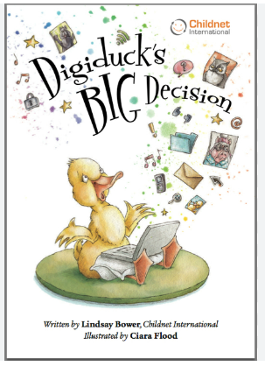 |  | 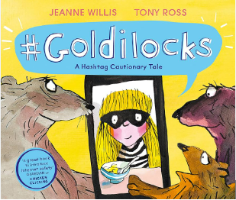 |  |  | 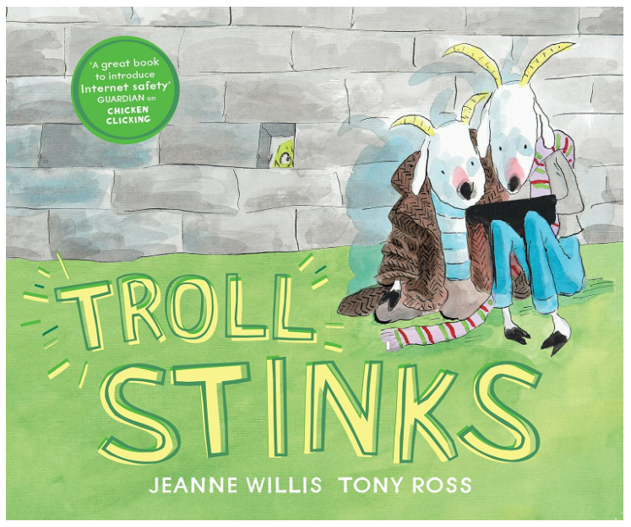 |  | 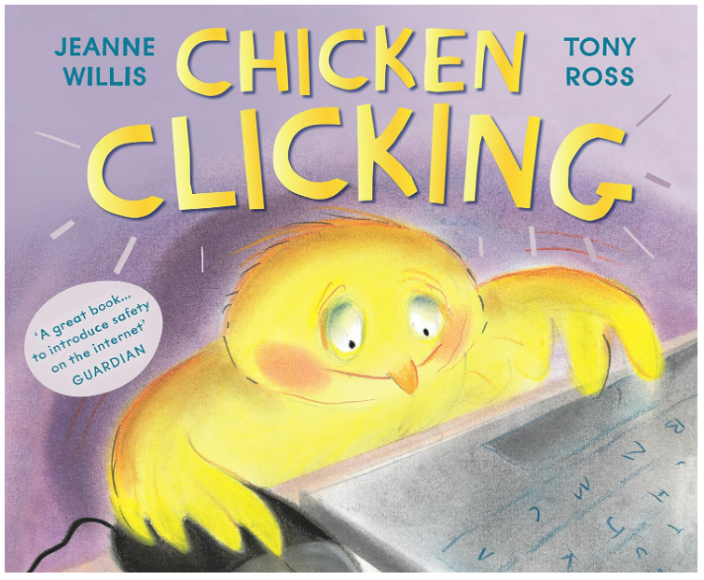 | 

